**AUTO INSURANCE CLAIM PREDICTION**

**BACHELOR OF TECHNOLOGY**

**IN**

**ELECTRONICS AND COMMUNICATION ENGINEERING**

**SUBMITTED BY**

**PIGILAM.SRIHAAS**

**Regd. No.: 20B91A04J1**

**Under Supervision of Mr.G.NAGARAJU**

**Henotic Technology Pvt Ltd, Hyderabad**

**(Duration: 6th June, 2023 to 8th August, 2023)**



**DEPARTMENT OF ELECTRONICS AND COMMUNICATION ENGINEERING**

**SAGI RAMA KRISHNAM RAJU ENGINEERING COLLEGE**

(An Autonomous Institution)

Approved by AICTE and affiliated to JNTU, Kakinada

BHIMAVARAM, ANDHRA PRADESH

**Table of Contents**

[**1.0** **Introduction** 4](https://docs.google.com/document/d/1gfr9E0B9uZmom45Yyf7Bn0SqYNkjY1O-Sv_gTzwbJ8o/edit#heading=h.3znysh7)

[**1.1.** **What are the different types of Machine Learning?** 4](https://docs.google.com/document/d/1gfr9E0B9uZmom45Yyf7Bn0SqYNkjY1O-Sv_gTzwbJ8o/edit#heading=h.tyjcwt)

[**1.2.** **Benefits of Using Machine Learning in Auto Insurance** 4](https://docs.google.com/document/d/1gfr9E0B9uZmom45Yyf7Bn0SqYNkjY1O-Sv_gTzwbJ8o/edit#heading=h.3dy6vkm)

[**1.3.** **About Industry**  5](https://docs.google.com/document/d/1gfr9E0B9uZmom45Yyf7Bn0SqYNkjY1O-Sv_gTzwbJ8o/edit#heading=h.1t3h5sf)

[**1.3.1** **AI / ML Role in Auto Insurance** 5](https://docs.google.com/document/d/1gfr9E0B9uZmom45Yyf7Bn0SqYNkjY1O-Sv_gTzwbJ8o/edit#heading=h.4d34og8)

[**2.0** **Auto Insurance Claims (your internship project)** 6](https://docs.google.com/document/d/1gfr9E0B9uZmom45Yyf7Bn0SqYNkjY1O-Sv_gTzwbJ8o/edit#heading=h.2s8eyo1)

[**2.1.** **Main Drivers for AI Auto Quote Analysis** 6](https://docs.google.com/document/d/1gfr9E0B9uZmom45Yyf7Bn0SqYNkjY1O-Sv_gTzwbJ8o/edit#heading=h.17dp8vu)

[**2.2.** **Internship Project - Data Link** 7](https://docs.google.com/document/d/1gfr9E0B9uZmom45Yyf7Bn0SqYNkjY1O-Sv_gTzwbJ8o/edit#heading=h.3rdcrjn)

[**3.0** **AI / ML Modelling and Results** 8](https://docs.google.com/document/d/1gfr9E0B9uZmom45Yyf7Bn0SqYNkjY1O-Sv_gTzwbJ8o/edit#heading=h.26in1rg)

[**3.1.** **Your Problem of Statement** 8](https://docs.google.com/document/d/1gfr9E0B9uZmom45Yyf7Bn0SqYNkjY1O-Sv_gTzwbJ8o/edit#heading=h.lnxbz9)

[**3.2.** **Data Science Project Life Cycle** 8](https://docs.google.com/document/d/1gfr9E0B9uZmom45Yyf7Bn0SqYNkjY1O-Sv_gTzwbJ8o/edit#heading=h.35nkun2)

[**3.2.1** **Data Exploratory Analysis** 9](https://docs.google.com/document/d/1gfr9E0B9uZmom45Yyf7Bn0SqYNkjY1O-Sv_gTzwbJ8o/edit#heading=h.1ksv4uv)

[**3.2.2** **Data Pre-processing** 9](https://docs.google.com/document/d/1gfr9E0B9uZmom45Yyf7Bn0SqYNkjY1O-Sv_gTzwbJ8o/edit#heading=h.44sinio)

[**3.2.2.1.** **Check the Duplicate and low variation data** 9](https://docs.google.com/document/d/1gfr9E0B9uZmom45Yyf7Bn0SqYNkjY1O-Sv_gTzwbJ8o/edit#heading=h.2jxsxqh)

[**3.2.2.2.** **Identify and address the missing variables** 10](https://docs.google.com/document/d/1gfr9E0B9uZmom45Yyf7Bn0SqYNkjY1O-Sv_gTzwbJ8o/edit#heading=h.z337ya)

[**3.2.2.3.** **Handling of Outliers** 10](https://docs.google.com/document/d/1gfr9E0B9uZmom45Yyf7Bn0SqYNkjY1O-Sv_gTzwbJ8o/edit#heading=h.3j2qqm3)

[**3.2.2.4.** **Categorical data and Encoding Techniques** 10](https://docs.google.com/document/d/1gfr9E0B9uZmom45Yyf7Bn0SqYNkjY1O-Sv_gTzwbJ8o/edit#heading=h.1y810tw)

[**3.2.2.5.** **Feature Scaling** 10](https://docs.google.com/document/d/1gfr9E0B9uZmom45Yyf7Bn0SqYNkjY1O-Sv_gTzwbJ8o/edit#heading=h.4i7ojhp)

[**3.2.3** **Selection of Dependent and Independent variables** 10](https://docs.google.com/document/d/1gfr9E0B9uZmom45Yyf7Bn0SqYNkjY1O-Sv_gTzwbJ8o/edit#heading=h.2xcytpi)

[**3.2.4** **Data Sampling Methods** 10](https://docs.google.com/document/d/1gfr9E0B9uZmom45Yyf7Bn0SqYNkjY1O-Sv_gTzwbJ8o/edit#heading=h.1ci93xb)

[**3.2.4.1.** **Stratified sampling** 10](https://docs.google.com/document/d/1gfr9E0B9uZmom45Yyf7Bn0SqYNkjY1O-Sv_gTzwbJ8o/edit#heading=h.3whwml4)

[**3.2.4.2.** **Simple random sampling** 11](https://docs.google.com/document/d/1gfr9E0B9uZmom45Yyf7Bn0SqYNkjY1O-Sv_gTzwbJ8o/edit#heading=h.2bn6wsx)

[**3.2.5** **Models Used for Development** 11](https://docs.google.com/document/d/1gfr9E0B9uZmom45Yyf7Bn0SqYNkjY1O-Sv_gTzwbJ8o/edit#heading=h.qsh70q)

[**3.2.5.1.** **Model 01** 11](https://docs.google.com/document/d/1gfr9E0B9uZmom45Yyf7Bn0SqYNkjY1O-Sv_gTzwbJ8o/edit#heading=h.3as4poj)

[**3.2.5.2.** **Model 02** 11](https://docs.google.com/document/d/1gfr9E0B9uZmom45Yyf7Bn0SqYNkjY1O-Sv_gTzwbJ8o/edit#heading=h.1pxezwc)

[**3.2.5.3.** **Model 03** 11](https://docs.google.com/document/d/1gfr9E0B9uZmom45Yyf7Bn0SqYNkjY1O-Sv_gTzwbJ8o/edit#heading=h.49x2ik5)

[**3.2.5.4.** **Model 04** 11](https://docs.google.com/document/d/1gfr9E0B9uZmom45Yyf7Bn0SqYNkjY1O-Sv_gTzwbJ8o/edit#heading=h.2p2csry)

[**3.2.5.5.** **Model 10** 11](https://docs.google.com/document/d/1gfr9E0B9uZmom45Yyf7Bn0SqYNkjY1O-Sv_gTzwbJ8o/edit#heading=h.147n2zr)

[**3.3.** **AI / ML Models Analysis and Final Results** 12](https://docs.google.com/document/d/1gfr9E0B9uZmom45Yyf7Bn0SqYNkjY1O-Sv_gTzwbJ8o/edit#heading=h.3o7alnk)

[**3.3.1** **Different Model codes** 12](https://docs.google.com/document/d/1gfr9E0B9uZmom45Yyf7Bn0SqYNkjY1O-Sv_gTzwbJ8o/edit#heading=h.23ckvvd)

[**3.3.2** **Random Forest Python Code** 12](https://docs.google.com/document/d/1gfr9E0B9uZmom45Yyf7Bn0SqYNkjY1O-Sv_gTzwbJ8o/edit#heading=h.ihv636)

[**3.3.3** **Extra Trees Python code** 12](https://docs.google.com/document/d/1gfr9E0B9uZmom45Yyf7Bn0SqYNkjY1O-Sv_gTzwbJ8o/edit#heading=h.32hioqz)

[**4.0** **Conclusions and Future work** 13](https://docs.google.com/document/d/1gfr9E0B9uZmom45Yyf7Bn0SqYNkjY1O-Sv_gTzwbJ8o/edit#heading=h.41mghml)

[**5.0** **References** 14](https://docs.google.com/document/d/1gfr9E0B9uZmom45Yyf7Bn0SqYNkjY1O-Sv_gTzwbJ8o/edit#heading=h.2grqrue)

[**6.0** **Appendices** 15](https://docs.google.com/document/d/1gfr9E0B9uZmom45Yyf7Bn0SqYNkjY1O-Sv_gTzwbJ8o/edit#heading=h.vx1227)

[**6.1.** **Python code Results** 15](https://docs.google.com/document/d/1gfr9E0B9uZmom45Yyf7Bn0SqYNkjY1O-Sv_gTzwbJ8o/edit#heading=h.3fwokq0)

[**6.2.** **List of Charts** 15](https://docs.google.com/document/d/1gfr9E0B9uZmom45Yyf7Bn0SqYNkjY1O-Sv_gTzwbJ8o/edit#heading=h.1v1yuxt)

[**6.2.1** **Chart 01: Total Quoted Premium** 15](https://docs.google.com/document/d/1gfr9E0B9uZmom45Yyf7Bn0SqYNkjY1O-Sv_gTzwbJ8o/edit#heading=h.4f1mdlm)

[**6.2.2** **Chart 02: Total Policy Premium** 15](https://docs.google.com/document/d/1gfr9E0B9uZmom45Yyf7Bn0SqYNkjY1O-Sv_gTzwbJ8o/edit#heading=h.2u6wntf)

[**6.2.3** **Chart 03: Quotes Trend with prediction for next 6 weeks** 15](https://docs.google.com/document/d/1gfr9E0B9uZmom45Yyf7Bn0SqYNkjY1O-Sv_gTzwbJ8o/edit#heading=h.19c6y18)

[**6.2.4** **Chart 04: BI Claims Paid by Marital Status** 16](https://docs.google.com/document/d/1gfr9E0B9uZmom45Yyf7Bn0SqYNkjY1O-Sv_gTzwbJ8o/edit#heading=h.3tbugp1)

**Abstract**

Abstract:

The auto insurance claim prediction project utilises artificial intelligence (AI) and machine learning (ML) techniques to predict the likelihood of an insurance claim being filed based on various factors. By leveraging historical data, the project aims to provide insurers with a tool to assess and manage risks effectively.

Keywords and their meanings:

1. Auto insurance: Insurance coverage for vehicles, protecting against damages, theft, and accidents.

2. Claim prediction: Forecasting the probability of an insurance claim being filed.

3. AI: Artificial Intelligence - The simulation of human intelligence in machines to perform tasks intelligently.

4. ML: Machine Learning - A subset of AI that enables systems to learn and improve from experience without explicit programming.

5. Prediction: Estimating or forecasting future outcomes based on available data and patterns.

6. Risk assessment: Evaluating the potential risks and uncertainties associated with insuring a policyholder or event.

7. Historical data: Past records and information used as a basis for analysis and prediction.

8. Feature engineering: The process of selecting and creating relevant input variables (features) for ML models.

9. Supervised learning: ML algorithms that learn from labelled data with known outcomes to make predictions on new data.

10. Ensemble learning: Combining multiple ML models to improve prediction accuracy and performance.

11. Evaluation metrics: Measures used to assess the performance of predictive models, such as accuracy, precision, recall, and F1-score.

12. Application interface: User interface or software platform where insurers can input information and obtain claim predictions.

13. Resource allocation: Optimal allocation and utilisation of resources, such as staff, finances, and materials, for efficient operations.

14. Policy premiums: The cost of insurance coverage paid by policyholders to insurers based on risk factors.

15. Claim management: The process of handling and processing insurance claims, including assessment, verification, and settlement.

The auto insurance claim prediction project leverages AI/ML to provide insurers with valuable insights for risk assessment, optimising resource allocation, and enhancing policy premiums. It improves efficiency, accuracy, and profitability in the insurance industry while offering a more personalised and tailored experience for policyholders.

# Introduction

With the increasing power of computer technology, companies and institutions can now store vast amounts of data at reduced costs. This exponential growth in available data presents a tremendous opportunity to unlock valuable information that was previously overlooked. However, the sheer size and complexity of these databases make manual analysis impractical, calling for automated systems to support the data exploration process.

In this context, Data Mining emerges as a crucial discipline that leverages automated systems to process large datasets already present in databases. By applying advanced algorithms, Data Mining uncovers hidden patterns, trends, and regularities within the data, enabling businesses to address complex problems and extract meaningful insights. Data Mining techniques often fall within the realm of Machine Learning, harnessing its learning capabilities to navigate the vast volumes of information.

The insurance industry faces a significant challenge in accurately pricing risks for individual customers. As risk varies widely among customers, understanding different risk factors becomes essential in predicting the likelihood and cost of insurance claims. This program aims to evaluate the performance of various statistical methods in predicting auto insurance claims based on driver characteristics, vehicle information, and driver/vehicle coverage details.

Several factors contribute to predicting auto insurance claims, including a driver's age, past accident history, and residence. However, this contest specifically focuses on the relationship between claims and vehicle characteristics, as well as other policy-associated attributes.

By conducting rigorous analysis and applying statistical models, this program seeks to develop predictive models that aid insurers in accurately assessing risk and setting appropriate insurance premiums. The insights gained from this study can optimize the pricing process, improve risk management strategies, and enhance overall decision-making within the insurance industry.

The project employs data-driven approaches, leveraging advanced techniques such as regression analysis, decision trees, and ensemble methods to uncover significant predictors of insurance claims. By leveraging large amounts of available data, this research contributes to the growing field of data-driven decision-making in the insurance industry.

Overall, this project addresses the crucial need for computational tools capable of handling large datasets and extracting valuable information. The application of Data Mining and Machine Learning techniques in the insurance domain represents a significant step towards improving risk assessment and enhancing the efficiency and profitability of insurance companies.

## What are the different types of Machine Learning?

Machine learning, a subfield of artificial intelligence, encompasses various types of algorithms and techniques. These can be broadly classified into three main categories: supervised learning, unsupervised learning, and reinforcement learning. Each type has its own characteristics, objectives, and applications. Let's explore these categories in more detail, along with additional examples:

1. Supervised Learning:

Supervised learning involves training a model using labelled data, where the input features and their corresponding output labels are provided. The model learns to generalize patterns from the labelled examples to make predictions or classify new, unseen instances. Examples of supervised learning algorithms include:

- Support Vector Machines (SVM): SVMs find a hyperplane that best separates different classes. They are effective for both classification and regression tasks and have been used in various applications, such as image recognition and text classification.

- Naive Bayes: This probabilistic algorithm is based on Bayes' theorem. It calculates the probability of a given instance belonging to a particular class, making it popular for spam filtering, sentiment analysis, and document classification.

- Random Forest: Random Forests are an ensemble learning method that combines multiple decision trees. They excel in tasks like classification and regression and are used in credit scoring, medical diagnosis, and stock market prediction.

- Gradient Boosting: Gradient Boosting algorithms build an ensemble of weak prediction models, gradually learning from their mistakes. Examples include AdaBoost, XGBoost, and LightGBM. These algorithms have achieved state-of-the-art results in various domains, including web search ranking and recommendation systems.

2. Unsupervised Learning:

Unsupervised learning involves training a model on unlabelled data, where the model identifies patterns, structures, or relationships without any predefined output labels. The objective is to discover hidden patterns or group similar instances together. Examples of unsupervised learning algorithms include:

- Clustering (e.g., K-means, DBSCAN): Clustering algorithms group similar data points together based on their features. They are useful for customer segmentation, anomaly detection, and image compression.

- Principal Component Analysis (PCA): PCA is a dimensionality reduction technique that transforms high-dimensional data into a lower-dimensional space while preserving important information. It aids visualization, feature extraction, and noise reduction.

- Association Rule Learning (e.g., Apriori): Association rule learning discovers relationships and dependencies among variables in a dataset. It has applications in market basket analysis, recommendation systems, and customer behaviour analysis.

- Autoencoders: Autoencoders are neural network models used for unsupervised feature learning and data compression. They have been employed in tasks like image denoising, anomaly detection, and generating synthetic data.

3. Reinforcement Learning:

Reinforcement learning involves an agent learning through interactions with an environment. The agent receives feedback in the form of rewards or penalties for its actions, allowing it to learn optimal strategies over time. Examples of reinforcement learning algorithms include:

- Q-Learning: Q-Learning is a model-free algorithm that learns through trial and error. The agent explores the environment, updating its Q-values to make better decisions. Q-Learning is commonly used in robotics, game-playing agents, and autonomous vehicle control.

- Deep Q-Networks (DQN): DQNs combine reinforcement learning with deep neural networks. They have achieved remarkable results in playing complex games by learning directly from raw sensory inputs.

- Policy Gradient Methods: These algorithms learn policies by optimizing the expected cumulative reward. Examples include Proximal Policy Optimization (PPO) and Trust Region Policy Optimization (TRPO). Policy gradient methods are effective in continuous action spaces and have been used in robotics, healthcare, and finance.

These are just a few examples of machine learning algorithms within each category. Machine learning continues to evolve, and researchers are constantly developing new techniques and algorithms to tackle diverse problems across various domains. Understanding the different types of machine learning allows practitioners to select the most appropriate approach for their specific tasks and applications.

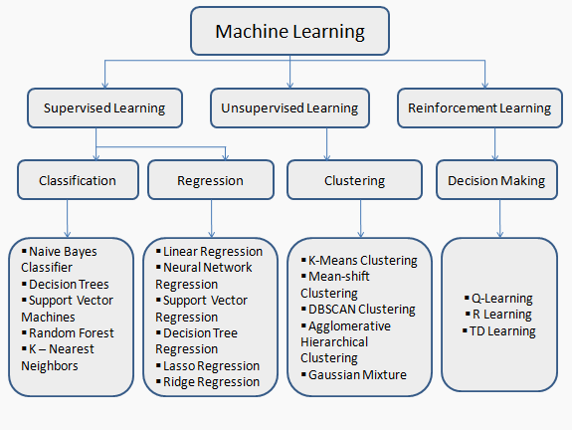

## About Industry (Auto Insurance)

The automobile insurance industry is experiencing a significant wave of transformations in recent years. With a growing focus on personalized insurance plans and intensifying market competition, this sector has reached a staggering milestone, surpassing the $200 billion mark as of 2018. This impressive growth underscores the importance for auto insurance organizations to prioritize their valued clientele, as there is no room for complacency in this dynamic landscape.

The market competition in the auto insurance industry has become increasingly cut-throat, with new and competent organizations emerging at a rapid pace. This heightened competition pushes insurance companies to continually innovate, improve their services, and deliver tailored solutions to meet the evolving needs of their customers. In this highly competitive environment, companies that fail to adapt and address customer demands risk falling behind their more agile counterparts.

To succeed in this evolving landscape, auto insurance companies are adopting various strategies to stand out in the market. One notable trend is the shift towards customized insurance plans that cater to individual policyholders' specific requirements. This customer-centric approach allows insurers to offer tailored coverage options, flexible pricing, and personalized discounts, enhancing the overall customer experience and satisfaction.

Furthermore, the industry is embracing advancements in technology to gain a competitive edge. Artificial Intelligence (AI) and Machine Learning (ML) are being employed to streamline various processes and improve efficiency. AI-powered chatbots and virtual assistants provide round-the-clock customer support, assisting policyholders with inquiries, policy management, and claims processing. ML algorithms analyse vast amounts of data to uncover patterns, assess risk factors, and prevent fraudulent activities, enabling insurers to make more accurate underwriting decisions and enhance overall risk management.

The emergence of big data analytics has also revolutionized the auto insurance sector. Insurance companies have access to a wealth of data, including customer profiles, vehicle information, and claim records. By leveraging advanced analytics techniques, insurers can extract valuable insights, identify trends, and make data-driven decisions. This enables them to optimize underwriting processes, enhance pricing models, and provide more personalized offerings to their customers.

The rise of autonomous vehicles presents both challenges and opportunities for the auto insurance industry. Insurers are adapting their policies and underwriting practices to account for the unique risks associated with self-driving cars. Assessing liability and determining coverage for accidents involving autonomous vehicles require new approaches, further fuelling innovation within the industry.

Digital transformation is another key aspect reshaping the auto insurance landscape. Insurers are embracing online platforms and mobile applications to streamline policy purchasing, claims processing, and policy management. This digitalization eliminates paperwork, enhances accessibility, and provides policyholders with convenient self-service options.

Moreover, collaborations and partnerships with technology startups and insurtech companies are gaining prominence. These collaborations allow auto insurers to leverage advanced technologies, data analytics platforms, and customer engagement tools. By joining forces with insurtech companies, traditional insurers can tap into innovative solutions, improve operational efficiency, and offer unique products and services that meet the evolving needs of their customers.

In conclusion, the auto insurance industry is undergoing significant transformations driven by the pursuit of customized insurance plans and intensified market competition. With the industry surpassing the $200 billion mark, it is imperative for auto insurance organizations to prioritize their valued clientele and stay agile in the face of increasing competition. By embracing technological advancements, leveraging data analytics, and adopting customer-centric strategies, auto insurers can thrive in this dynamic landscape and deliver superior experiences to their policyholders.



### AI / ML Role in Auto Insurance

Machine Learning is a sub-set of artificial intelligence where computer algorithms are used to autonomously learn from data. Machine learning (ML) is getting more and more attention and is becoming increasingly popular in many other industries. Within the insurance industry, there is more application of ML regarding the claims.

Machine Learning (ML) plays a significant role in the auto insurance industry, particularly in the domain of claims processing and risk assessment. ML algorithms have the ability to analyze vast amounts of data, identify patterns, and make predictions, enabling insurers to make more accurate decisions and streamline their operations.

One of the key applications of ML in auto insurance is claims prediction and fraud detection. By analyzing historical claims data, ML models can learn from patterns and characteristics of past claims to predict the likelihood of future claims. This helps insurance companies assess risk and determine appropriate premiums. ML algorithms can also detect anomalies and patterns indicative of fraudulent claims, allowing insurers to take proactive measures to prevent fraud and protect their businesses.

ML is also used in pricing models within the auto insurance industry. Traditional pricing models rely on demographic factors such as age, gender, and location. However, ML techniques can incorporate additional variables, such as driving behavior and vehicle telematics data, to create more personalized and accurate pricing models. This allows insurers to offer competitive premiums based on individual risk profiles, promoting fairness and attracting customers with customized pricing options.

Furthermore, ML algorithms are employed in underwriting processes to evaluate risks associated with insuring a specific driver or vehicle. By analyzing various data sources, including driving records, credit history, and external factors such as weather conditions, ML models can assess risk more accurately and efficiently. This helps insurers make informed decisions when determining policy eligibility, coverage limits, and pricing.

ML also plays a crucial role in improving customer experience and engagement in the auto insurance industry. By leveraging ML-powered chatbots and virtual assistants, insurers can provide round-the-clock customer support, answer policy-related queries, and assist with claims filing and status updates. These virtual assistants can understand natural language, allowing policyholders to interact seamlessly and receive immediate responses, enhancing customer satisfaction and reducing the need for manual intervention.

Additionally, ML techniques are used to analyze and process unstructured data sources, such as social media feeds, customer reviews, and online forums. Sentiment analysis and natural language processing algorithms can extract valuable insights from these sources, helping insurers understand customer sentiments, identify emerging trends, and improve their products and services accordingly.

ML also contributes to risk management within the auto insurance industry. By continuously monitoring and analyzing driving behavior data collected through telematics devices, ML algorithms can identify risky driving patterns, such as speeding or sudden braking. Insurers can then provide feedback to policyholders, incentivize safe driving habits, and offer personalized recommendations to mitigate risks.

The integration of ML with telematics and connected car technologies further enhances the auto insurance industry. Through real-time data collection and analysis, ML algorithms can identify driving patterns, vehicle performance, and potential risks. This allows insurers to offer usage-based insurance, where premiums are based on actual driving behavior rather than general assumptions, promoting fair pricing and encouraging safer driving habits.

In summary, ML has revolutionized various aspects of the auto insurance industry. From claims prediction and fraud detection to personalized pricing models and enhanced customer experiences, ML algorithms enable insurers to make data-driven decisions, improve risk assessment, and optimize their operations. As the industry continues to evolve, the role of ML in auto insurance will likely expand, bringing further advancements and benefits to insurers and policyholders alike.

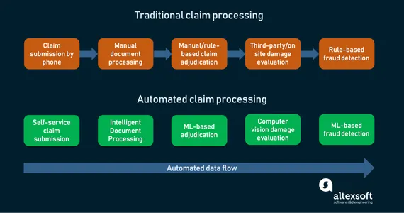

# Auto Insurance Claims Prediction

Auto insurance premiums have historically been priced on underwriting and rating. Underwriting is a process where the insurer assesses the applicant’s risk. They do this by incorporating personal information and internal claims data into weighted algorithms. Insurers then look at rating factors to predict the likelihood of a claim’s submission. The rating assigns a price based on the projected cost to the insurer of assuming financial responsibility of potential claims. Auto insurance premiums fluctuate with the projected risk to the insurer. A policyholder can lower their premium by taking on more risk. For instance, the policyholder can choose to drop optional coverages or increase the deductible. A deductible is the out-of-pocket portion of the claim for which the driver is responsible.

The main factors for auto insurance BI claims are Location, Age, Gender, Marital status, driving experience, driving record, Claims history, Credit history, Previous insurance coverage, Vehicle type, Vehicle use, Miles driven, Coverages and deductibles.

Location plays a significant role in auto insurance claims. Areas with higher population densities, congested traffic, or higher crime rates are associated with increased risk of accidents, theft, and vandalism. Insurers consider geographic location to assess the probability of claims and adjust premiums accordingly.

Age is another important factor affecting auto insurance claims. Younger and inexperienced drivers are statistically more likely to be involved in accidents compared to older, more experienced drivers. Insurers take age into account to evaluate the risk profile of drivers and determine premiums.

Gender is also considered in claims prediction. Historical data suggests that certain genders may exhibit different driving behaviors or have varying risk profiles. Insurers analyze gender-related data to predict claims likelihood and adjust premiums accordingly.

Marital status is a factor that insurers consider in claims prediction. Married individuals tend to have lower claim frequencies compared to single individuals. This may be attributed to factors such as increased responsibility, stability, and potentially safer driving habits. Insurers use marital status as a rating factor to assess risk and determine premiums.

Driving experience and driving record are crucial indicators of claims probability. Drivers with more years of driving experience and a clean record are generally associated with lower claims likelihood. Insurers assess the driver's history of accidents, traffic violations, and claims to evaluate the risk they pose and adjust premiums accordingly.

Claims history provides valuable insights into a driver's past behavior. If a driver has a history of frequent claims, it indicates a higher likelihood of future claims. Insurers consider this information when predicting claims and determining premiums.

Credit history is a factor that may impact auto insurance claims prediction. Studies have shown a correlation between creditworthiness and the likelihood of filing claims. Insurers use credit history as a rating factor to evaluate risk and set premiums.

Previous insurance coverage is also taken into account when predicting claims. Drivers with a history of continuous insurance coverage and no coverage gaps are generally considered more responsible and lower risk. Insurers consider the driver's prior insurance information to assess claims likelihood.

Vehicle type is an important factor in claims prediction. Different vehicle models have varying safety features, theft rates, and repair costs. Insurers evaluate the make, model, and year of the vehicle to determine the risk associated with insuring it.

Vehicle use, such as personal or commercial use, can also impact claims likelihood. Vehicles used for business purposes may be subjected to higher mileage, increased exposure to accidents, or different driving conditions. Insurers take vehicle use into account to assess risk and set premiums accordingly.

Miles driven is a factor that insurers consider for claims prediction. Higher annual mileage increases the chances of accidents and potential claims. Insurers assess the estimated annual mileage to evaluate the risk profile of drivers and adjust premiums accordingly.

Coverages and deductibles chosen by policyholders also influence claims prediction. Policyholders who opt for higher coverage limits or lower deductibles are more likely to file claims. Insurers analyze the coverage options and deductibles selected by policyholders to assess risk and determine premiums.

In conclusion, auto insurance claims prediction relies on a multitude of factors, including location, age, gender, marital status, driving experience, driving record, claims history, credit history, previous insurance coverage, vehicle type, vehicle use, miles driven, and coverages and deductibles. By analyzing and considering these factors, insurers can accurately predict the likelihood of claims, set appropriate premiums, and effectively manage risk in the auto insurance industry.

## Main Drivers for AI Auto Quote Analysis

Predictive modelling allows for simultaneous consideration of many variables and quantification of their overall effect. When a large number of claims are analysed, patterns regarding the characteristics of the claims that drive loss development begin to emerge.

The following are the main drivers which influencing the Claims Analytics:

|  |  |
| --- | --- |
| * Policy Characteristics * Exposures * Limits and Deductibles * Coverages and Perils * Insured Characteristics * Credit Information * Prior loss experience * Payment history * Geography based on insured locations * Auto Repair Costs * Jurisdictional Orientation * Demographics * Crime * Agency Characteristics * Exclusive Agents * Independent Agents | * Claim information * FNOL * Claimant data (Credit info, geography, social data, etc.) * Other participants (insured, doctors, lawyers, witnesses, etc.) * Cause, type of Injury/Damage * Injury or damaged object * Coverage * Loss Location * Date and time of Loss and Report * Weather at time & location of loss * Details from Prior Claims * from same insured * from same claimant * from same location * Household Characteristics |

## Internship Project - Data Link

The internship project data has taken from Kaggle and the link is www.kaggle.com/datasets/srihaaspigilam/auto-insurance-claim-predicition

# AI / ML Modelling and Results

## Your Problem of Statement

Predictive models are most effective when they are constructed using a company’s own historical claims data since this allows the model to recognize the specific nature of a company’s exposure as well as its claims practices. The construction of the model also involves input from the company throughout the process, as well as consideration of industry leading claims practices and benchmarks.

Predictive modelling can be used to quantify the impact to the claims department resulting from the failure to meet or exceed claim service leading practices. It can also be used to identify the root cause of claim leakage. Proper use of predictive modelling will allow for potential savings across two dimensions:

* Early identification of claims with the potential for high leakage, thereby allowing for the proactive management of the claim
* Recognition of practices that are unnecessarily increasing claims settlement payments

## Data Science Project Life Cycle

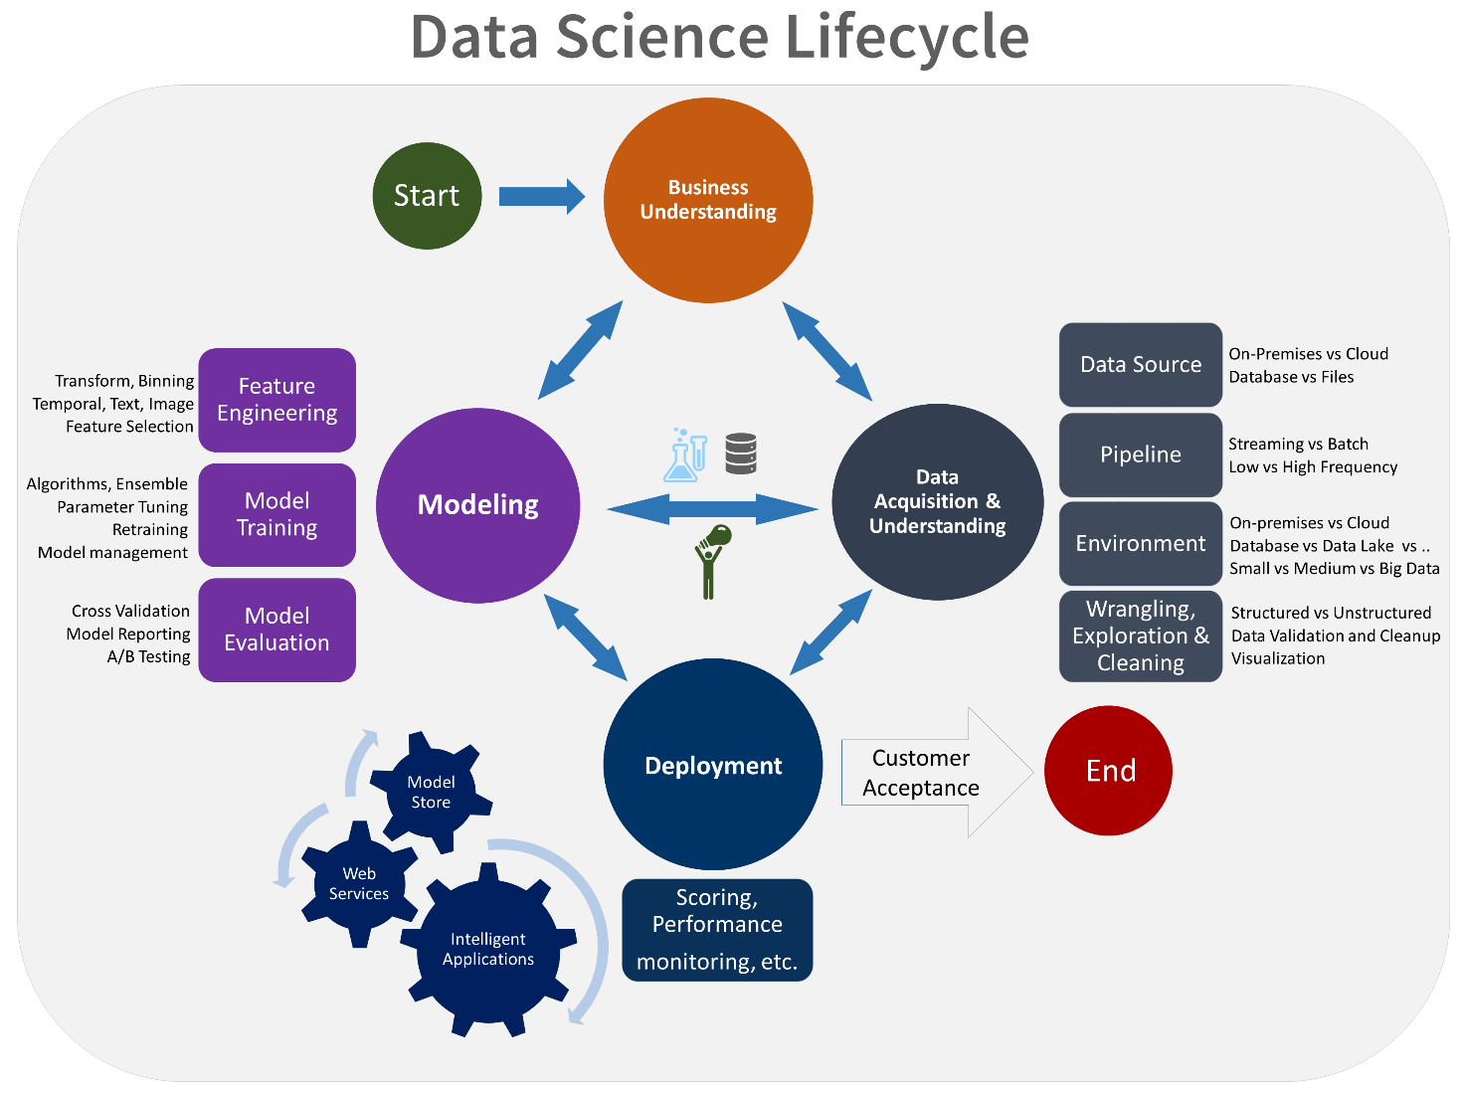Data Science is a multidisciplinary field of study that combines programming skills, domain expertise and knowledge of statistics and mathematics to extract useful insights and knowledge from data.

### Data Exploratory Analysis

Exploratory data analysis has been done on the data to look for relationship and correlation between different variables and to understand how they impact or target variable.

The exploratory analysis is done for Auto Quote / Policy Conversion with different parameters and all the charts are presented in **Appendices 6.2 - List of charts (6.2.1 to 6.2.9)**

### Data Pre-processing

We removed variables which do not affect our target variable (Claimed) as they may add noise and also increase our computation time, we checked the data for anomalous data points and outliers. We did principal component analysis on the data set to filter out unnecessary variables and to select only the important variables which have greater correlation with our target variable.

#### Check the Duplicate and low variation data

Checked the duplicate values if any in the given data set and there are no duplicate values present in the given data set .

Variation is a measure of how spread out the data is around the centre of the data.

A small variance indicates that the data points tend to be very close to the mean, and to each other. A high variance indicates that the data points are very spread out from the mean, and from one another.

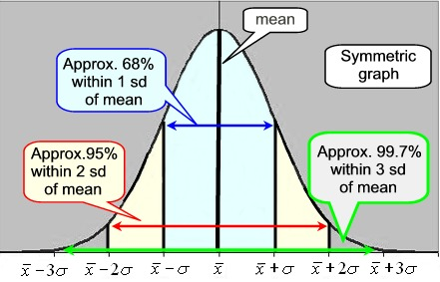

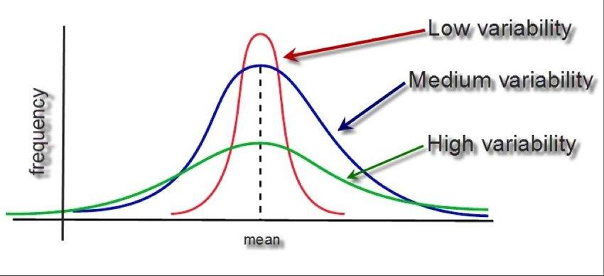

A high variance tells us that the collected data has higher variability, and the data is generally further from the mean. A low variance tells us the opposite, that the collected data is generally similar, and does not deviate.much from men.

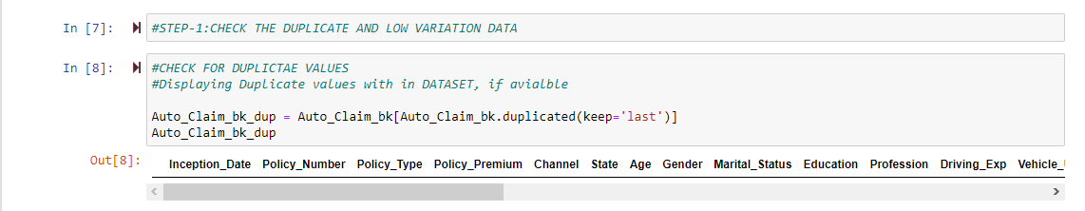

#### Identify and address the missing variables

Checked whether there are missing values or not.There were missing values in the columns ‘Claim_Number’, ‘Accident_Date’, ‘Road_Type’, ‘Accident_Severity’.In all columns the no.of missing values are(24047) nearly equal to no records(27225) in the data set.

Missing data in machine learning is a type of data that contains “None” or “NaN” type of values. One should take care of the missing data while dealing with machine learning algorithms and training. Missing data can be filled using [basic python programming](https://courses.analyticsvidhya.com/courses/introduction-to-data-science), pandas library, and a sci-kit learn library named SimpleImputer. Handling missing values using the sci-kit learn's library SimpleImputer is the easiest and most convenient method of all the other missing data handling methods.By using SimpleImputer one can fill the null values which are ’numerical’ or as well as ‘categorical’ values.

We use heat maps plots for visualising the missing data and can understand precisely the missing data and its characteristics

We use Simple Imputer in order to handle our Data preprocessing steps in order to handle the missing categorical data in columns ‘Claim_Number’, ‘Accident_Date’, ‘Road_Type’, ‘Accident_Severity’.

The basic syntax or structure of a SimpleImputer initialization is:

SimpleImputer(*missing_values=nan*, *strategy='mean'*, *fill_value=None*, *verbose=0*, *copy=True*, *add_indicator=False*)

Strategy: it is the method by using which we want to fill in the missing values, the value of the strategy could be:

.Mean

.Median

.constant

.most_frequent

Heat map showing the missing or null values:

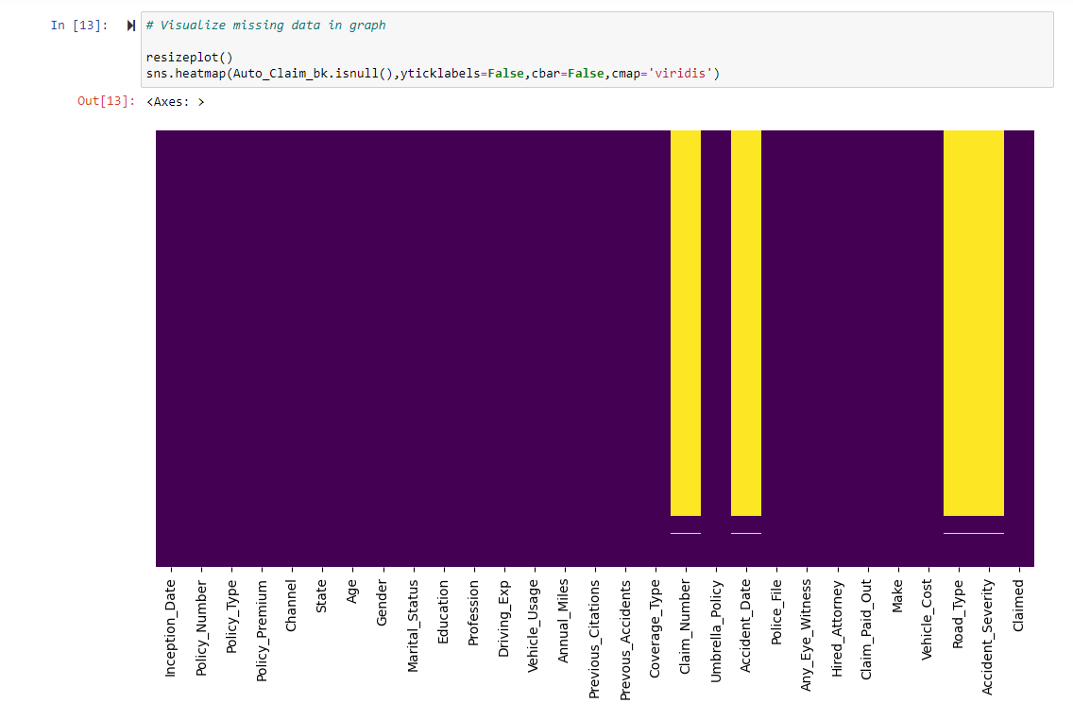

Using Simple Imputer:

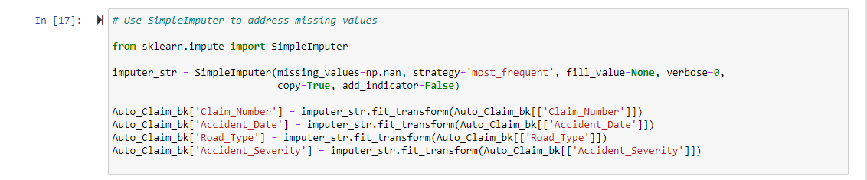

Graph that shows no missing values after using Simple Imputer:

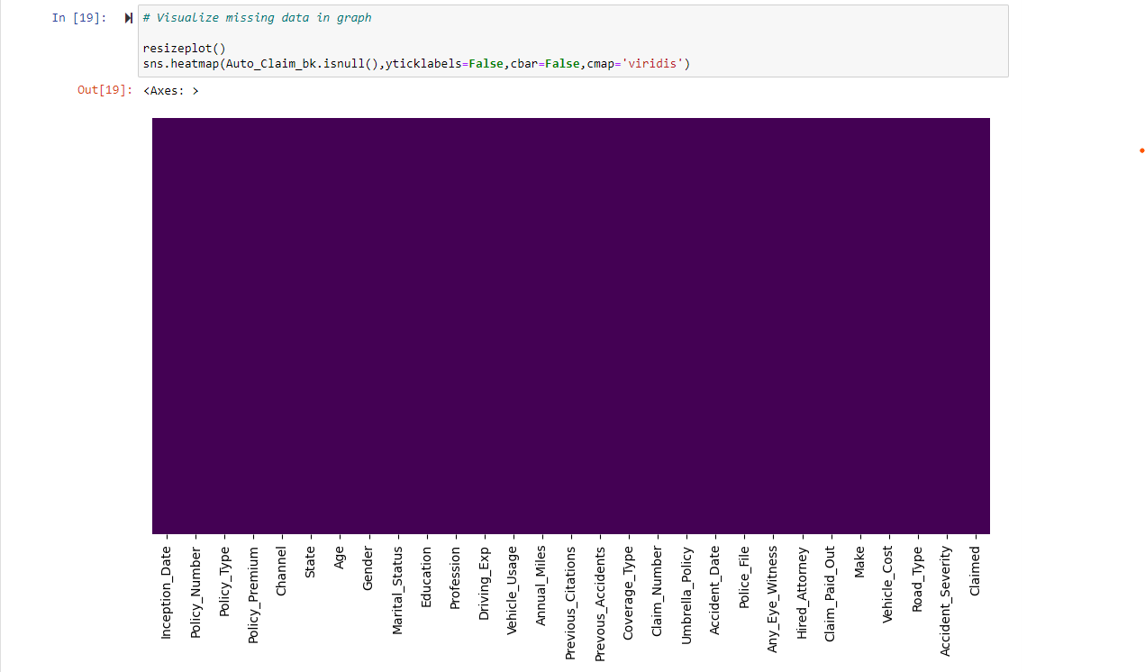

#### Handling of Outliers:

Outliers are data points that significantly deviate from the majority of the data in a dataset. They are observations that are unusually distant from other observations and can have a substantial impact on statistical analyses and machine learning models. Outliers can occur due to various reasons, such as measurement errors, data entry mistakes, or genuinely rare events.

Identifying and dealing with outliers is essential in data analysis to ensure accurate and reliable results. There are several methods to detect and remove outliers, including:

1. Z-Score Method: The Z-score measures how many standard deviations a data point is away from the mean. Data points with a Z-score above a certain threshold (typically 2 or 3) are considered outliers. These outliers can be removed from the dataset.

2. Interquartile Range (IQR) Method: The IQR is a measure of statistical dispersion, representing the range between the first quartile (25th percentile) and the third quartile (75th percentile) of the data. Any data point below the first quartile minus a threshold value (typically 1.5 times the IQR) or above the third quartile plus the threshold value is considered an outlier and can be removed.

3. Boxplots: Boxplots provide a visual representation of the distribution of data and help identify outliers. Data points outside the whiskers of the boxplot (usually defined as 1.5 times the IQR) are considered outliers.

4. Mahalanobis Distance: The Mahalanobis distance measures the distance between a data point and the center of a distribution, taking into account the covariance between variables. Data points with a high Mahalanobis distance can be considered outliers and removed.

5. Density-Based Outlier Detection: Methods like DBSCAN (Density-Based Spatial Clustering of Applications with Noise) and LOF (Local Outlier Factor) identify outliers based on the density of data points. Points with low density or significantly different densities from their neighbours are considered outliers.

6. Visual Inspection: Sometimes outliers can be identified by visually inspecting the data. Data points that seem unusual or do not follow the expected patterns can be considered outliers.

Once outliers are identified, there are different approaches to handling them:

1. Removal: Outliers can be removed from the dataset, especially if they are due to data errors or have a significant impact on the analysis. However, caution should be exercised as removing outliers can affect the representativeness of the data.

2. Transformation: In some cases, transforming the data using mathematical functions like logarithmic or power transformations can mitigate the effect of outliers. This approach can make the data more normally distributed and reduce the impact of extreme values.

3. Winsorization: Winsorization replaces outliers with values close to the cutoff points (e.g., replacing values above the 95th percentile with the value at the 95th percentile). This method reduces the impact of outliers while preserving the overall distribution of the data.

4. Binning: Binning involves dividing the data into bins or intervals and assigning outlier values to the nearest bin boundaries. This method can help reduce the impact of outliers while preserving the overall structure of the data.

5. Model-based Approaches: Outliers can be handled by incorporating robust statistical models or machine learning algorithms that are less sensitive to extreme values. These models can downweight or assign lower importance to outliers during the analysis.

It is important to note that the decision to remove or handle outliers depends on the specific context, the nature of the data, and the objectives of the analysis. Careful consideration should be given to the potential consequences of outlier removal and the impact on the overall analysis or modelling process.

These all above methods and factors are checked only if the variable is continuous. (Eg:Age).Outliers are only performed on the continuous variables.

In our Data set we have variables which have outliers and were removed and stored into another specific data frames.We first visualize the data graphically and apply bell curve or gaussian method and find the outliers and remove them.

**For eg:**In our Data set we have a variable ’Policy_Premium’ which is continuous, we analysed it graphically and applied bell curve method here are the results below

Normal Histogram Plot:

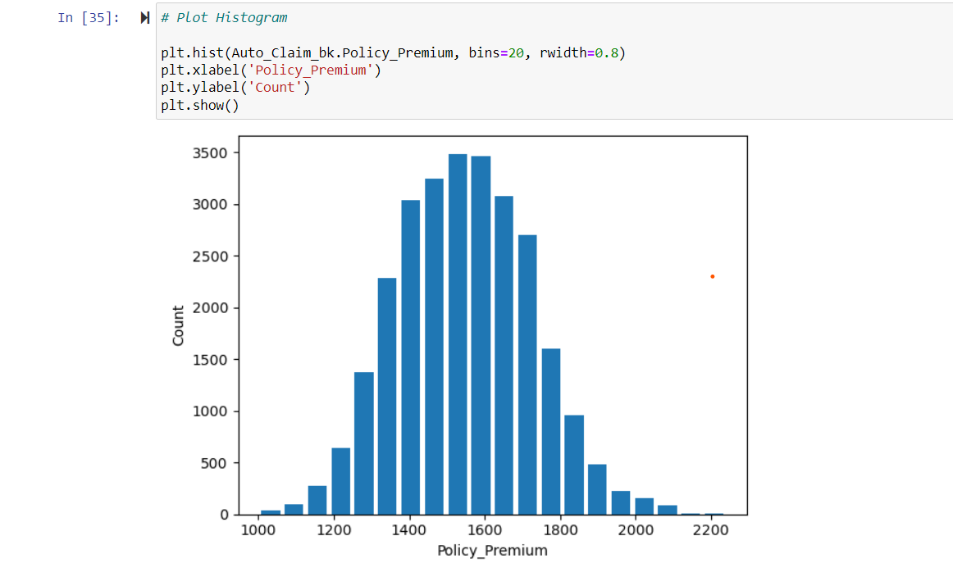

Bell curve or Gaussian plot: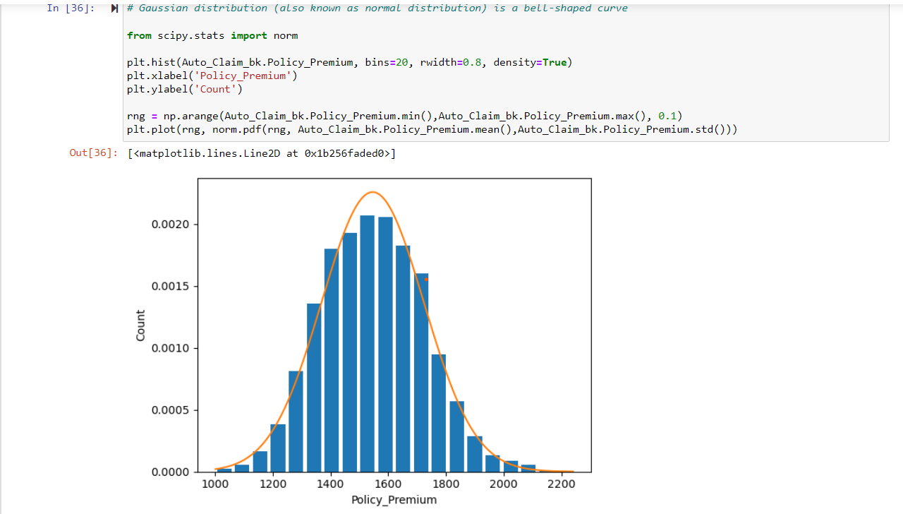

Outliers in the variable:

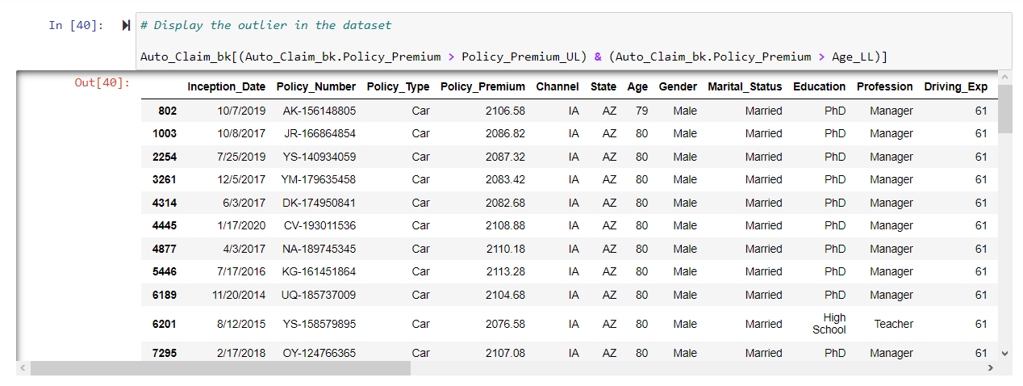

In this above manner we check whether the outliers present or not in the given continuous variables available in the Data set.

#### Categorical data and Encoding Techniques

Categorical data refers to a form of information that can be stored and identified based on their names or labels. It is a type of qualitative data that can be grouped into categories instead of being measured numerically.

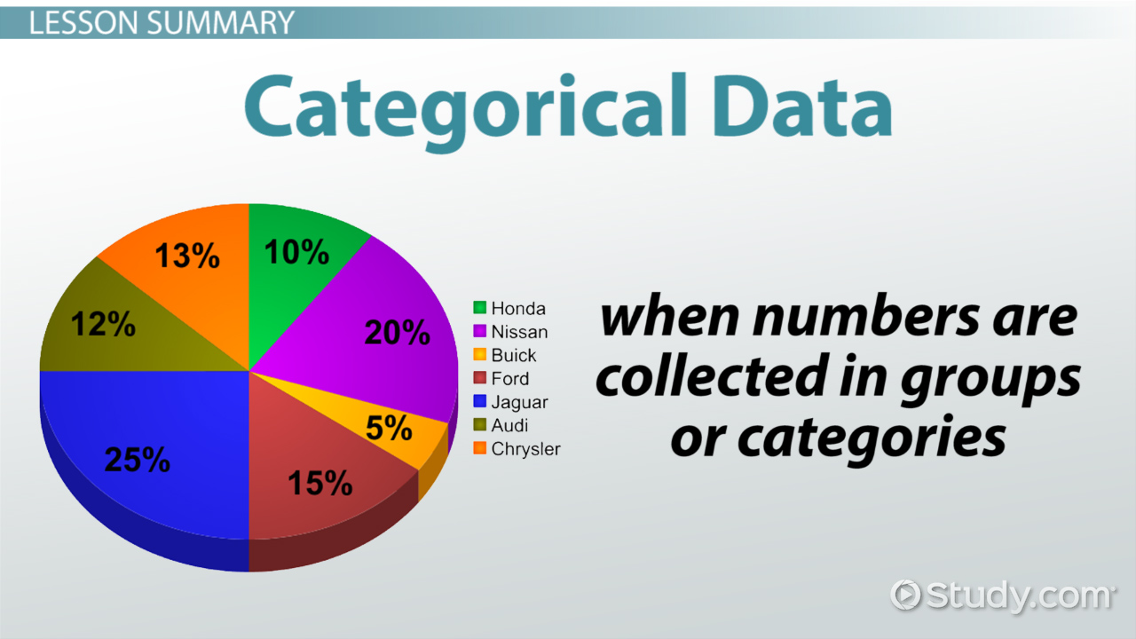

Examples of categorical variables are race, sex, age group, and educational level.There are three types of categorical variables: binary, nominal, and ordinal variables

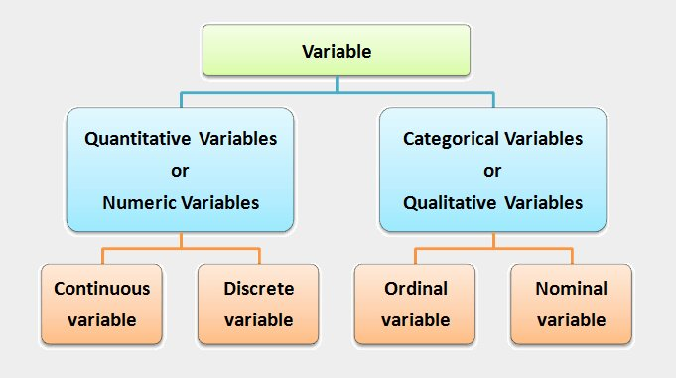

In our data set we separate the categorical and numerical variables other than our target variable “Claimed”.

A machine learning algorithm needs to be able to understand the data it receives. For example, categories such as “small”, “medium”, and “large” need to be converted into numbers. To solve that, we can for example convert them into numeric labels with “1” for small, “2” for medium, and “3” for large

There are plenty of methods to encode categorical variables into numeric and each method comes with its own advantages and disadvantages.ways to encode categorical variables:

1. One-hot/dummy encoding
2. Label / Ordinal encoding
3. Target encoding
4. Frequency / count encoding
5. Binary encoding
6. Feature Hashing

After separating the numerical and categorical variables, the categorical variables are 'Inception_Date', 'Policy_Number', 'Policy_Type', 'Channel', 'State', 'Gender', 'Marital_Status', 'Education', 'Profession', 'Vehicle_Usage',

'Coverage_Type', 'Claim_Number', 'Umbrella_Policy', 'Accident_Date', 'Police_File', 'Any_Eye_Witness', 'Hired_Attorney', 'Make', 'Road_Type', 'Accident_Severity' in our Data set.

We perform encoding techniques based on the variable and its type and its sub divisions and characteristics.

We manually encoded for some categorical variables like 'Education', 'Marital_Status', 'Profession' and Label encoder for the other categorical variables variables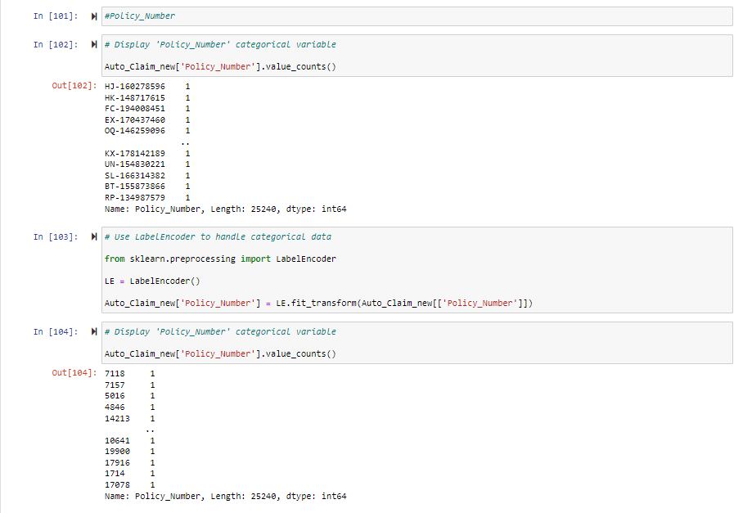

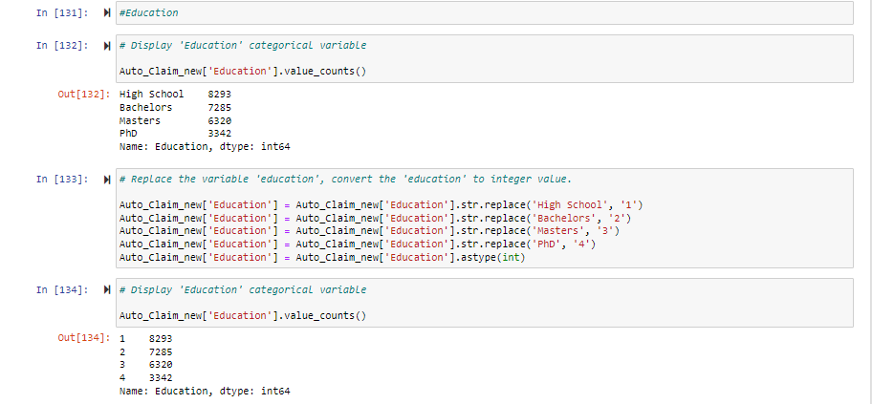

#### Feature Scaling

Feature scaling is a method used to normalize the range of independent variables or features of data. In data processing, it is also known as data normalization and is generally performed during the data preprocessing step.

When working with datasets that contain features with different scales, certain machine learning algorithms may be affected. For example, algorithms based on distance calculations, such as k-nearest neighbors (KNN) or support vector machines (SVM), can be sensitive to the magnitude of features. In such cases, feature scaling becomes essential to ensure fair comparisons and accurate model performance.

There are two common methods for feature scaling: standardization (or z-score normalization) and normalization (or min-max scaling).

1. Standardization:

Standardization transforms the features to have a mean of zero and a standard deviation of one. This technique preserves the shape of the distribution while centering the data around zero and adjusting its spread. The formula for standardization is:

z = (x - mean) / standard deviation

where z is the standardized value, x is the original value, mean is the mean of the feature, and standard deviation is the standard deviation of the feature.

2. Normalization:

Normalization, also known as min-max scaling, rescales the features to a specific range, typically between 0 and 1. It transforms the values proportionally, maintaining the relative relationships between the data points. The formula for normalization is:

x_normalized = (x - min) / (max - min)

where x_normalized is the normalized value, x is the original value, min is the minimum value of the feature, and max is the maximum value of the feature.

Feature scaling is typically applied to numerical features, but it is not necessary for all machine learning algorithms. Some algorithms, such as decision trees or random forests, are invariant to feature scaling, while others, like logistic regression or neural networks, can benefit from scaled features.

It is important to note that feature scaling should be performed on the training data and then applied consistently to the test or validation data using the same scaling parameters (mean, standard deviation, min, max) obtained from the training data. This ensures that the data remains consistent and comparable across different sets.

By applying feature scaling as part of the data preprocessing step, the impact of different scales or units in the features can be mitigated, allowing machine learning algorithms to work more effectively and produce more accurate and reliable results.

We applied Min-Max Scaler to our data set

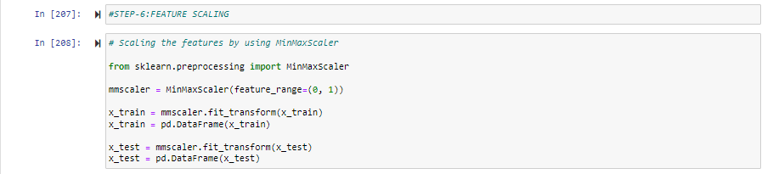

### Selection of Dependent and Independent variables

The dependent or target variable here is ‘Claimed’ which tells us if a particular policy holder has filed a claim or not the target variable is selected based on our business problem and what we are trying to predict.

In machine learning, selecting the appropriate dependent (target) and independent (predictor) variables is a crucial step in building effective predictive models. The selection process involves identifying which variables should be used to predict the target variable and which variables should be excluded.

### Data Sampling Methods

The data we have is highly unbalanced data so we used some sampling methods which are used to balance the target variable so we our model will be developed with good accuracy and precision. We used one Sampling method.

Data sampling methods are techniques used to select a subset of data from a larger dataset for analysis or model training. Sampling is often employed when working with large datasets to reduce computational complexity, improve efficiency, or address specific research or analysis objectives. Here are some commonly used data sampling methods:

1. Simple Random Sampling: In this method, each data point in the population has an equal chance of being selected. Random samples are taken without any bias, making it a straightforward and unbiased sampling approach.

2. Stratified Sampling: This technique involves dividing the population into homogeneous subgroups or strata based on certain characteristics. Samples are then randomly selected from each stratum in proportion to their representation in the population. Stratified sampling ensures that each subgroup is adequately represented in the sample, making it useful when certain subgroups are of particular interest.

3. Cluster Sampling: With cluster sampling, the population is divided into clusters or groups, and a random selection of clusters is made. All individuals within the selected clusters are included in the sample. Cluster sampling is useful when it is not practical or cost-effective to access individual data points directly.

4. Systematic Sampling: Systematic sampling involves selecting data points at regular intervals from an ordered list or dataset. For example, every nth data point is chosen as part of the sample. Systematic sampling can be efficient and convenient when data points have a sequential or periodic structure.

5. Oversampling and Undersampling: These techniques are used in imbalanced datasets where one class or category is underrepresented compared to others. Oversampling involves randomly duplicating or creating synthetic samples from the minority class to balance the dataset. Undersampling, on the other hand, randomly removes samples from the majority class to achieve balance. These techniques help address the issue of class imbalance in machine learning tasks.

6. Stratified Random Sampling: This method combines elements of stratified sampling and random sampling. The population is divided into strata, and random samples are taken from each stratum. The difference from stratified sampling is that the samples within each stratum are randomly selected rather than being chosen proportionally to their representation.

7. Convenience Sampling: Convenience sampling involves selecting data points based on their easy accessibility or convenience. This method is often used when researchers or analysts select readily available data points without applying a random or systematic selection process. While convenient, this sampling method may introduce bias and limit generalizability.

8. Purposive Sampling: Purposive sampling, also known as judgmental or selective sampling, involves deliberately selecting data points that possess specific characteristics or meet certain criteria. This method is subjective and relies on the researcher's or analyst's judgment, expertise, or specific research objectives.

It is crucial to carefully consider the sampling method based on the research goals, available resources, representativeness requirements, and the characteristics of the dataset. The chosen sampling method should aim to provide a representative and unbiased subset of data for analysis or model training.

#### Over Sampling

Within [statistics](https://en.wikipedia.org/wiki/Statistics), **oversampling** and **undersampling** in data analysis are techniques used to adjust the class distribution of a [data set](https://en.wikipedia.org/wiki/Data_set) (i.e. the ratio between the different classes/categories represented). These terms are used both in statistical sampling, survey design methodology and in [machine learning](https://en.wikipedia.org/wiki/Machine_learning).

Random Oversampling involves supplementing the training data with multiple copies of some of the minority classes. Oversampling can be done more than once (2x, 3x, 5x, 10x, etc.) This is one of the earliest proposed methods, that is also proven to be robust.[[3]](https://en.wikipedia.org/wiki/Oversampling_and_undersampling_in_data_analysis#cite_note-3) Instead of duplicating every sample in the minority class, some of them may be randomly chosen with replacement

#### Under sampling

Undersampling is a technique to balance uneven datasets by keeping all of the data in the minority class and decreasing the size of the majority class. It is one of several techniques data scientists can use to extract more accurate information from originally imbalanced datasets.

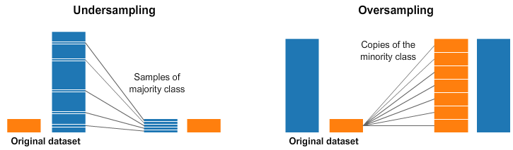

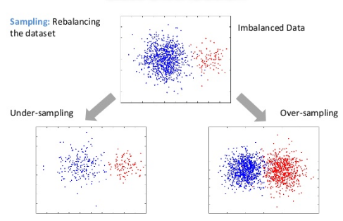

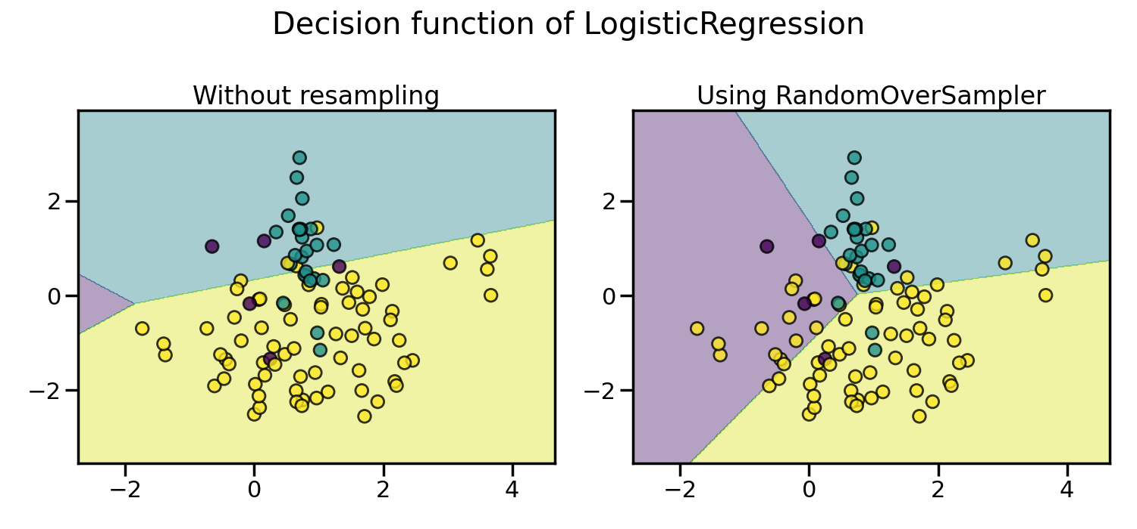

We split the dataset into train dataset which contains 70% of the total data and test dataset with the remaining 30% of the data

### Models Used for Development

We built our predictive models by using the following Seven algorithms

#### Logistic regression Model:

Logistic regression is a statistical modelling technique used for binary classification problems, where the outcome variable has two possible classes. It estimates the probability of an event occurring based on the values of independent variables. Here is a brief description of logistic regression, its key characteristics, steps involved in building a logistic regression model, advantages, disadvantages, limitations, and a comparison with other popular algorithms.

Key Characteristics of Logistic Regression:

1. Probability Estimation: Logistic regression models the relationship between independent variables and the probability of an event occurring. It uses a logistic function (sigmoid function) to transform the linear combination of predictors into a value between 0 and 1, representing the probability.

2. Linear Decision Boundary: Logistic regression uses a decision boundary (usually set at 0.5 probability) to classify instances into one of the two classes. If the predicted probability is above the threshold, the instance is classified as the positive class; otherwise, it is classified as the negative class.

3. Coefficient Interpretation: The model estimates coefficients for each independent variable, representing the log-odds (logarithm of the odds) of the event occurring. These coefficients can be exponentiated to obtain odds ratios, providing insights into the direction and magnitude of the relationship between predictors and the outcome.

Steps Involved in Building a Logistic Regression Model:

1. Data Preparation: Clean and preprocess the data, handle missing values, categorical variables, and perform feature scaling if necessary.

2. Model Specification: Select the relevant independent variables (features) based on domain knowledge and statistical significance.

3. Model Fitting: Use maximum likelihood estimation to estimate the coefficients that maximise the likelihood of observing the given data.

4. Model Evaluation: Assess the performance of the model using evaluation metrics such as accuracy, precision, recall, F1 score, and area under the receiver operating characteristic curve (AUC-ROC).

Advantages of Logistic Regression:

1. Interpretability: Logistic regression provides interpretable coefficients, allowing for the understanding and explanation of the impact of independent variables on the probability of the outcome.

2. Simple Implementation: Logistic regression is relatively easy to implement and computationally efficient, making it suitable for large datasets.

3. Handling of Categorical Predictors: Logistic regression can handle both categorical and continuous predictors without requiring complex transformations.

Disadvantages and Limitations of Logistic Regression:

1. Linear Relationship Assumption: Logistic regression assumes a linear relationship between independent variables and the log-odds of the outcome. Non-linear relationships may require additional transformations or the use of alternative models.

2. Sensitivity to Outliers: Logistic regression can be sensitive to outliers, which may impact the estimated coefficients and the decision boundary.

3. Lack of Robustness: Logistic regression may not perform well when there is multicollinearity among predictors or when the classes are imbalanced.

Comparison with Other Algorithms:

Comparing logistic regression with ten different algorithms in detail would exceed the response limit. However, here are ten popular algorithms and a brief comparison with logistic regression:

1. Decision Trees: Logistic regression provides probabilistic predictions and interpretable coefficients, while decision trees offer non-linear relationships and can handle both categorical and numerical data.

2. Random Forest: Random forests aggregate multiple decision trees to improve accuracy, while logistic regression provides interpretability and simplicity.

3. Support Vector Machines (SVM): SVMs can handle complex decision boundaries, but logistic regression is often preferred when interpretability is crucial.

4. Naive Bayes: Naive Bayes assumes independence between features, while logistic regression can handle correlated predictors and provide interpretable coefficients.

5. K-Nearest Neighbors (KNN): KNN uses the nearest neighbors for classification, while logistic regression provides probabilistic predictions and interpretable coefficients.

6. Gradient Boosting: Gradient boosting algorithms like XGBoost and LightGBM

can handle complex relationships, but logistic regression is simpler and more interpretable.

7. Neural Networks: Neural networks are powerful for complex tasks but lack interpretability compared to logistic regression.

8. Linear Discriminant Analysis (LDA): LDA assumes normally distributed predictors, while logistic regression has no such assumption.

9. Ensemble Methods: Ensemble methods like AdaBoost and Bagging combine multiple models, while logistic regression provides simplicity and interpretability.

10. Gaussian Processes: Gaussian processes model the distribution over functions, providing flexible predictions but lacking interpretability compared to logistic regression.

In summary, logistic regression is a popular algorithm for binary classification tasks. It offers interpretability, simple implementation, and the ability to handle both categorical and continuous predictors. However, it assumes a linear relationship, is sensitive to outliers, and may not be suitable for complex non-linear problems compared to other algorithms. The choice of algorithm depends on the specific problem, data characteristics, and the importance of interpretability versus complexity.

#### Decision Tree Model:

Decision Trees are popular machine learning algorithms that can be used for both classification and regression tasks. They are hierarchical models that make decisions by partitioning the data based on features or attributes. Here is a brief description of Decision Trees, their key characteristics, steps involved in building a Decision Tree model, advantages, disadvantages, limitations, and a comparison with other 10 algorithms.

Key Characteristics of Decision Trees:

1. Interpretability: Decision Trees provide clear and interpretable rules that can be easily understood and visualised, making them useful for explaining the reasoning behind predictions.

2. Non-linear Relationships: Decision Trees can capture non-linear relationships between features and the target variable without requiring complex mathematical transformations.

3. Handling both Numerical and Categorical Data: Decision Trees can handle both numerical and categorical data as inputs, making them versatile for a wide range of datasets.

4. Feature Selection: Decision Trees inherently perform feature selection by evaluating the importance of features based on their ability to split the data effectively.

Steps Involved in Building a Decision Tree Model:

1. Attribute Selection: The algorithm selects the best attribute or feature at each node to split the data, aiming to maximise the separation of classes or minimise the impurity of the resulting subsets.

2. Splitting: The selected attribute is used to split the data into multiple branches, creating new child nodes.

3. Recursive Partitioning: The splitting process is recursively applied to each child node until a stopping criterion is met, such as reaching a maximum depth, achieving a minimum number of instances in a node, or achieving pure or homogeneous classes.

4. Leaf Node Labelling: The leaf nodes are labelled with the majority class or the predicted value based on the instances in that leaf node.

Advantages of Decision Trees:

1. Interpretability: Decision Trees provide a transparent and intuitive representation of the decision-making process, making it easy to understand and interpret the results.

2. Handling Non-linear Relationships: Decision Trees can capture complex non-linear relationships between features and the target variable without requiring complex transformations.

3. Feature Importance: Decision Trees provide a measure of feature importance, allowing users to identify the most influential features in the decision-making process.

Disadvantages and Limitations of Decision Trees:

1. Overfitting: Decision Trees are prone to overfitting, especially when they become too complex and are allowed to grow without constraints. Techniques like pruning and setting a maximum depth can help mitigate overfitting.

2. Lack of Robustness: Decision Trees are sensitive to small changes in the data, which can lead to different tree structures or decision rules.

3. Unbalanced Classes: Decision Trees can struggle with imbalanced class distributions, as they tend to favour the majority class and may not perform well on the minority class.

Comparison with Other 10 Algorithms:

1. Logistic Regression: Logistic Regression provides interpretable coefficients and probabilistic predictions, while Decision Trees offer non-linear relationships and can handle both categorical and numerical data.

2. Random Forest: Random Forest builds multiple Decision Trees and combines their predictions to improve accuracy and reduce overfitting.

3. Support Vector Machines (SVM): SVMs create a decision boundary to separate classes, while Decision Trees provide interpretable rules.

4. Naive Bayes: Naive Bayes assumes independence between features, while Decision Trees can handle correlated predictors and provide feature importance.

5. K-Nearest Neighbors (KNN): KNN uses the nearest neighbors for classification, while Decision Trees provide interpretable rules and handle non-linear relationships.

6. Gradient Boosting: Gradient Boosting algorithms like XGBoost and LightGBM create Decision Trees sequentially to improve accuracy.

7. Neural Networks: Neural Networks can handle complex relationships, but they lack interpretability compared to Decision Trees.

8. Linear Discriminant Analysis (LDA): LDA assumes normally distributed predictors,

while Decision Trees have no such assumption.

9. Ensemble Methods: Ensemble methods like AdaBoost and Bagging combine multiple models, including Decision Trees, to improve performance.

10. Gaussian Processes: Gaussian Processes model the distribution over functions, providing flexible predictions but lacking interpretability compared to Decision Trees.

In summary, Decision Trees are versatile and interpretable machine learning algorithms that can handle both numerical and categorical data. They provide clear decision rules and feature importance measures. However, they are prone to overfitting, sensitive to data changes, and can struggle with imbalanced classes. The choice between Decision Trees and other algorithms depends on the specific problem, data characteristics, interpretability requirements, and the need for handling non-linear relationships.

#### Random Forest Model:

Random Forest is an ensemble learning method that combines multiple decision trees to improve prediction accuracy and handle complex datasets. Each decision tree in a Random Forest is built on a randomly sampled subset of the data and features. Here is a brief description of Random Forest, its key characteristics, steps involved in building a Random Forest model, advantages, disadvantages, limitations, and a comparison with other 10 algorithms.

Key Characteristics of Random Forest:

1. Ensemble Learning: Random Forest combines multiple decision trees to make predictions, providing robustness and reducing overfitting.

2. Random Sampling: Random Forest randomly selects subsets of the data and features for building individual decision trees, introducing diversity and reducing the correlation between trees.

3. Feature Importance: Random Forest measures the importance of features based on how much they contribute to reducing the impurity or error in the predictions.

4. Handling High-Dimensional Data: Random Forest performs well on high-dimensional datasets and can handle a large number of features without requiring feature selection.

Steps Involved in Building a Random Forest Model:

1. Random Sampling: Randomly select subsets of the original dataset (bootstrapping) to create multiple training datasets.

2. Building Decision Trees: For each training dataset, build a decision tree using a subset of randomly selected features.

3. Voting and Prediction: Predict the class (for classification) or estimate the value (for regression) by aggregating the predictions of individual decision trees through majority voting or averaging.

Advantages of Random Forest:

1. High Accuracy: Random Forest generally provides higher prediction accuracy compared to individual decision trees by reducing overfitting and combining multiple models.

2. Robustness: Random Forest is robust to outliers and noisy data due to the averaging effect of multiple decision trees.

3. Feature Importance: Random Forest can measure the importance of features, allowing for feature selection and understanding the impact of variables on predictions.

Disadvantages and Limitations of Random Forest:

1. Lack of Interpretability: Random Forest is less interpretable compared to individual decision trees as it involves multiple trees and complex decision-making.

2. Computational Complexity: Building and training a Random Forest with a large number of trees and features can be computationally expensive.

3. Overfitting: Although Random Forest reduces overfitting compared to individual decision trees, it can still be prone to overfitting if the number of trees is too high or the model is excessively complex.

Comparison with Other 10 Algorithms:

1. Logistic Regression: Random Forest can handle non-linear relationships, while Logistic Regression assumes a linear relationship.

2. Decision Trees: Random Forest is an ensemble of decision trees, providing better generalisation and reducing overfitting compared to individual decision trees.

3. Support Vector Machines (SVM): SVMs create a decision boundary, while Random Forest focuses on building multiple decision trees.

4. Naive Bayes: Naive Bayes assumes independence between features, while Random Forest considers interactions between features.

5. K-Nearest Neighbors (KNN): KNN uses the nearest neighbors for classification, while Random Forest builds multiple decision trees.

6. Gradient Boosting: Gradient Boosting algorithms like XGBoost and LightGBM sequentially build decision trees, while Random Forest builds them independently.

7. Neural Networks: Neural Networks can handle complex relationships, but Random Forest provides interpretability and robustness.

8. Linear Discriminant Analysis (LDA): LDA assumes normally distributed predictors, while Random Forest has no such assumption.

9. Ensemble Methods: Random Forest is an ensemble method itself, but different ensemble methods combine models differently to improve performance.

10. Gaussian Processes: Gaussian Processes model the distribution over functions, providing flexibility but lacking the interpretability of Random Forest.

In summary, Random Forest is an ensemble learning method that combines multiple decision trees to improve prediction accuracy. It is robust, handles high

-dimensional data, and provides feature importance measures. However, it lacks interpretability compared to individual decision trees, can be computationally expensive, and still susceptible to overfitting. The choice between Random Forest and other algorithms depends on the specific problem, data characteristics, interpretability requirements, and the need for handling non-linear relationships and feature importance.

#### Extra Trees Model:

Extra Trees, also known as Extremely Randomised Trees, is an ensemble learning algorithm that builds multiple decision trees and combines their predictions. It is similar to Random Forest but differs in how it selects features and splits nodes. Here is a brief description of Extra Trees, its key characteristics, steps involved in building an Extra Trees model, advantages, disadvantages, limitations, and a comparison with other 10 algorithms.

Key Characteristics of Extra Trees:

1. Ensemble Learning: Extra Trees combines multiple decision trees to make predictions, providing robustness and reducing overfitting.

2. Random Feature Selection: Unlike Random Forest, Extra Trees randomly selects features at each node and makes the split based on random thresholds, which adds more randomness to the model.

3. High Variance: Extra Trees tends to have higher variance compared to Random Forest due to its increased randomness in feature selection and node splitting.

4. Feature Importance: Extra Trees can measure the importance of features based on how much they contribute to reducing the impurity or error in the predictions.

Steps Involved in Building an Extra Trees Model:

1. Random Feature Sampling: Randomly select subsets of features from the original dataset for each decision tree.

2. Building Decision Trees: For each subset of features, build a decision tree using random thresholds for feature splits.

3. Voting and Prediction: Predict the class (for classification) or estimate the value (for regression) by aggregating the predictions of individual decision trees through majority voting or averaging.

Advantages of Extra Trees:

1. Reduced Variance: Extra Trees introduces more randomness in feature selection and node splitting, reducing the variance and potential overfitting compared to individual decision trees.

2. Fast Training: Extra Trees can be faster to train compared to other ensemble methods like Random Forest since it does not require computing optimal splits.

3. Robust to Outliers: Extra Trees is robust to outliers and noisy data due to the averaging effect of multiple decision trees.

Disadvantages and Limitations of Extra Trees:

1. Lack of Interpretability: Extra Trees is less interpretable compared to individual decision trees as it involves multiple trees and random feature selection.

2. Increased Bias: The increased randomness in feature selection and node splitting can introduce additional bias to the model compared to Random Forest.

3. Computational Complexity: Although Extra Trees can be faster to train, it can still be computationally expensive for large datasets or a large number of trees.

Comparison with Other 10 Algorithms:

1. Logistic Regression: Extra Trees can handle non-linear relationships, while Logistic Regression assumes a linear relationship.

2. Decision Trees: Extra Trees is an ensemble of decision trees, providing better generalisation and reducing overfitting compared to individual decision trees.

3. Support Vector Machines (SVM): SVMs create a decision boundary, while Extra Trees focuses on building multiple decision trees.

4. Naive Bayes: Naive Bayes assumes independence between features, while Extra Trees considers interactions between features.

5. K-Nearest Neighbors (KNN): KNN uses the nearest neighbours for classification, while Extra Trees builds multiple decision trees.

6. Gradient Boosting: Gradient Boosting algorithms like XGBoost and LightGBM sequentially build decision trees, while Extra Trees builds them independently.

7. Neural Networks: Neural Networks can handle complex relationships, but Extra Trees provide interpretability and robustness.

8. Linear Discriminant Analysis (LDA): LDA assumes normally distributed predictors, while Extra Trees has no such assumption.

9. Ensemble Methods: Extra Trees is an ensemble method itself, but different ensemble methods combine models differently to improve performance.

10. Gaussian Processes: Gaussian Processes model the distribution over functions, providing flexibility but lacking the interpretability of Extra Trees.

In summary, Extra Trees is an ensemble learning algorithm that combines multiple decision trees with random feature selection and node splitting.

It reduces variance, handles outliers, and can be faster to train. However, it is less interpretable, introduces increased bias, and can be computationally expensive. The choice between Extra Trees and other algorithms depends on the specific problem, data characteristics, interpretability requirements, and the trade-off between variance and bias.

#### KNN Model:

K-Nearest Neighbours (KNN) is a non-parametric supervised learning algorithm used for classification and regression tasks. It classifies data points based on their proximity to other data points in the feature space. Here is a brief description of KNN, its key characteristics, steps involved in building a KNN model, advantages, disadvantages, limitations, and a comparison with other 10 algorithms.

Key Characteristics of KNN:

1. Instance-Based Learning: KNN is an instance-based learning algorithm that stores the entire training dataset and uses it for making predictions.

2. Proximity-Based Classification: KNN classifies a data point by finding the K nearest neighbors based on a distance metric and assigning the majority class among the neighbors.

3. Non-Parametric: KNN does not make assumptions about the underlying data distribution and does not estimate parameters.

4. Lazy Learning: KNN performs minimal computation during the training phase and defers most of the work to the prediction phase.

Steps Involved in Building a KNN Model:

1. Selecting K: Determine the number of neighbors (K) to consider during classification or regression.

2. Calculating Distances: Compute the distance between the target data point and all other data points in the training dataset.

3. Identifying Neighbors: Select the K nearest neighbors based on the calculated distances.

4. Voting and Prediction: For classification, determine the majority class among the neighbors to assign the class label. For regression, calculate the average or weighted average of the target values of the neighbors.

Advantages of KNN:

1. Simplicity: KNN is easy to understand and implement, making it a good starting point for beginners.

2. No Training Phase: KNN does not require an explicit training phase since it stores the entire training dataset.

3. Non-Parametric: KNN can handle complex data distributions without assuming any specific form.

Disadvantages and Limitations of KNN:

1. Computational Complexity: As the size of the training dataset increases, the prediction time of KNN can become computationally expensive.

2. Sensitivity to Feature Scaling: KNN is sensitive to the scale of features, so feature scaling is often necessary.

3. Curse of Dimensionality: KNN performance deteriorates as the number of dimensions (features) increases, known as the curse of dimensionality.

Comparison with Other 10 Algorithms:

1. Logistic Regression: KNN is non-parametric, while Logistic Regression assumes a linear relationship between features and target variable.

2. Decision Trees: KNN makes predictions based on local neighbors, while Decision Trees make decisions based on hierarchical splits.

3. Support Vector Machines (SVM): SVMs create a decision boundary, while KNN considers local neighborhoods.

4. Naive Bayes: Naive Bayes assumes independence between features, while KNN considers relationships based on proximity.

5. Random Forest: KNN is an instance-based learning algorithm, while Random Forest combines multiple decision trees.

6. Gradient Boosting: Gradient Boosting algorithms like XGBoost and LightGBM sequentially build decision trees, while KNN relies on nearest neighbors.

7. Neural Networks: Neural Networks can model complex relationships, while KNN performs nearest neighbor classification.

8. Linear Discriminant Analysis (LDA): LDA assumes normally distributed predictors, while KNN does not make any distributional assumptions.

9. Ensemble Methods: KNN is an individual classifier, while ensemble methods combine multiple models for improved performance.

10. Gaussian Processes: Gaussian Processes model the distribution over functions, providing flexibility compared to the instance-based nature of KNN.

In summary, KNN is a simple yet powerful instance-based learning algorithm that classifies data points based on their proximity to neighbors. It is easy to understand and implement, but it can be computationally expensive

and sensitive to feature scaling. The choice between KNN and other algorithms depends on the specific problem, data characteristics, interpretability requirements, and the trade-off between simplicity and performance.

#### Support Vector Machines Model :

Support Vector Machines (SVM) is a powerful supervised learning algorithm used for classification and regression tasks. It constructs a hyperplane or set of hyperplanes in a high-dimensional space that can be used for classification or regression. Here is a brief description of SVM, its key characteristics, steps involved in building an SVM model, advantages, disadvantages, limitations, and a comparison with other 10 algorithms.

Key Characteristics of SVM:

1. Maximum Margin Classifier: SVM aims to find the hyperplane that maximizes the margin or distance between different classes, allowing for better generalization to unseen data.

2. Kernel Trick: SVM can efficiently handle non-linear data by transforming it into a higher-dimensional space using kernel functions.

3. Support Vectors: SVM uses a subset of training data called support vectors, which are the data points closest to the decision boundary.

4. Margin and Soft Margin: SVM can incorporate a soft margin to allow for some misclassification of training examples, balancing between maximizing the margin and minimizing errors.

Steps Involved in Building an SVM Model:

1. Data Preprocessing: Prepare and preprocess the data by handling missing values, encoding categorical variables, and performing feature scaling.

2. Selecting a Kernel: Choose an appropriate kernel function based on the characteristics of the data. Common kernels include linear, polynomial, and radial basis function (RBF).

3. Model Training: Train the SVM model by optimizing the margin and support vectors using optimization techniques such as Quadratic Programming or Sequential Minimal Optimization.

4. Hyperparameter Tuning: Fine-tune the hyperparameters of the SVM model, such as the regularization parameter (C) and kernel-specific parameters, using techniques like cross-validation.

Advantages of SVM:

1. Effective in High-Dimensional Spaces: SVM can handle high-dimensional data and is effective in cases where the number of features is larger than the number of samples.

2. Versatile and Flexible: SVM supports different kernel functions, allowing it to handle non-linear data and capture complex relationships.

3. Robust to Overfitting: SVM includes regularization to prevent overfitting, which helps generalize well to unseen data.

Disadvantages and Limitations of SVM:

1. Sensitivity to Hyperparameters: SVM performance can be sensitive to the choice of kernel and hyperparameters, requiring careful tuning.

2. Computational Complexity: Training an SVM model can be computationally expensive, especially for large datasets.

3. Lack of Interpretability: SVM models can be less interpretable compared to simpler algorithms like logistic regression.

Comparison with Other 10 Algorithms:

1. Logistic Regression: SVM aims to find the maximum margin, while logistic regression estimates probabilities using a logistic function.

2. Decision Trees: SVM finds a global decision boundary, while decision trees recursively split the feature space.

3. K-Nearest Neighbors (KNN): KNN classifies based on local neighborhoods, while SVM finds a global decision boundary.

4. Naive Bayes: Naive Bayes assumes feature independence, while SVM does not make any distributional assumptions.

5. Random Forest: Random Forest combines multiple decision trees, while SVM is a single classifier.

6. Gradient Boosting: Gradient Boosting builds an ensemble of weak learners, while SVM constructs a single optimal hyperplane.

7. Neural Networks: Neural Networks are highly flexible and can model complex relationships, while SVM finds a global decision boundary.

8. Linear Discriminant Analysis (LDA): LDA maximizes class separability, while SVM maximizes the margin between classes.

9. Ensemble Methods: SVM can be used as a base classifier in ensemble methods like AdaBoost or Gradient Boosting.

10. Gaussian Processes: Gaussian Processes model the distribution over functions, providing a probabilistic framework, while SVM is a discriminative classifier.

In summary, SVM is a versatile algorithm that finds an optimal decision boundary

to separate classes using a maximum margin approach. It is effective in high-dimensional spaces and can handle non-linear data. However, SVM requires careful parameter tuning and can be computationally expensive. The choice between SVM and other algorithms depends on the data characteristics, interpretability needs, computational resources, and the trade-off between performance and simplicity.

#### [NaiveBaye](http://localhost:8888/notebooks/Data%20Science/data%20by%20sir/day%205/12-A-NaiveBayes-01.ipynb)s Model:

Naive Bayes is a probabilistic classifier based on Bayes' theorem and assumes independence between features. It is commonly used for text classification and is known for its simplicity and efficiency. Here is a brief description of Naive Bayes, its key characteristics, steps involved in building a Naive Bayes model, advantages, disadvantages, limitations, and a comparison with other 10 algorithms.

Key Characteristics of Naive Bayes:

1. Probabilistic Classifier: Naive Bayes calculates the probability of a sample belonging to a particular class based on the probabilities of its features.

2. Conditional Independence: Naive Bayes assumes that the features are conditionally independent given the class label, which simplifies the calculation of probabilities.

3. Fast Training and Prediction: Naive Bayes has a fast training process since it only requires calculating probabilities and simple statistical operations.

Steps Involved in Building a Naive Bayes Model:

1. Data Preprocessing: Prepare the data by handling missing values, encoding categorical variables, and performing feature scaling if required.

2. Feature Selection: Select relevant features that have a significant impact on the target variable or remove irrelevant features.

3. Model Training: Estimate the conditional probability distributions for each feature given each class using the training data.

4. Probability Calculation: Calculate the prior probabilities of each class and use Bayes' theorem to calculate the posterior probabilities of the classes given the features.

5. Model Evaluation: Evaluate the performance of the Naive Bayes model using appropriate evaluation metrics such as accuracy, precision, recall, or F1 score.

Advantages of Naive Bayes:

1. Simplicity and Efficiency: Naive Bayes is simple to understand and implement, requiring fewer computational resources compared to more complex algorithms.

2. Fast Training and Prediction: Naive Bayes has a fast training process and can make predictions quickly.

3. Handles High-Dimensional Data: Naive Bayes performs well in high-dimensional data scenarios, such as text classification, where the number of features is large.

Disadvantages and Limitations of Naive Bayes:

1. Independence Assumption: The assumption of feature independence may not hold true in some real-world scenarios, leading to suboptimal performance.

2. Sensitivity to Irrelevant Features: Naive Bayes can be sensitive to irrelevant features, which may affect its accuracy.

3. Lack of Model Interpretability: Naive Bayes provides probabilities rather than explicit explanations for predictions, limiting its interpretability.

Comparison with Other 10 Algorithms:

1. Logistic Regression: Naive Bayes assumes feature independence, while logistic regression does not make this assumption.

2. Decision Trees: Naive Bayes is a probabilistic model, while decision trees recursively split the feature space based on information gain or Gini impurity.

3. K-Nearest Neighbors (KNN): KNN classifies based on local neighborhoods, while Naive Bayes calculates probabilities based on global feature probabilities.

4. Random Forest: Random Forest combines multiple decision trees, while Naive Bayes is a single probabilistic classifier.

5. Gradient Boosting: Gradient Boosting builds an ensemble of weak learners, while Naive Bayes is a single classifier based on probabilistic calculations.

6. Support Vector Machines (SVM): Naive Bayes is a probabilistic model, while SVM aims to find an optimal decision boundary between classes.

7. Neural Networks: Neural Networks are highly flexible and can model complex relationships, while Naive Bayes assumes feature independence.

8. Linear Discriminant Analysis (LDA): LDA maximizes class separability, while Naive Bayes calculates class probabilities based on feature probabilities.

9. Ensemble Methods: Naive Bayes can be used as a base classifier in ensemble methods like AdaBoost or Bagging.

10. Gradient Des

cent: Gradient Descent is an optimization algorithm used in various models, while Naive Bayes is a probabilistic classifier.

Overall, Naive Bayes is a simple and efficient algorithm suitable for tasks with high-dimensional data and probabilistic modeling requirements. However, its performance depends on the independence assumption and the relevance of features to the target variable. Comparisons with other algorithms can help identify the most suitable approach for specific datasets and problem domains.

## AI / ML Models Analysis and Final Results

We used our train dataset to build the above models and used our test data to check the accuracy and performance of our models.

We used confusion matrix to check accuracy, Precision, Recall and F1 score of our models and compare and select the best model for given auto dataset of size ~ 272252 policies.

### OVER SAMPLING:

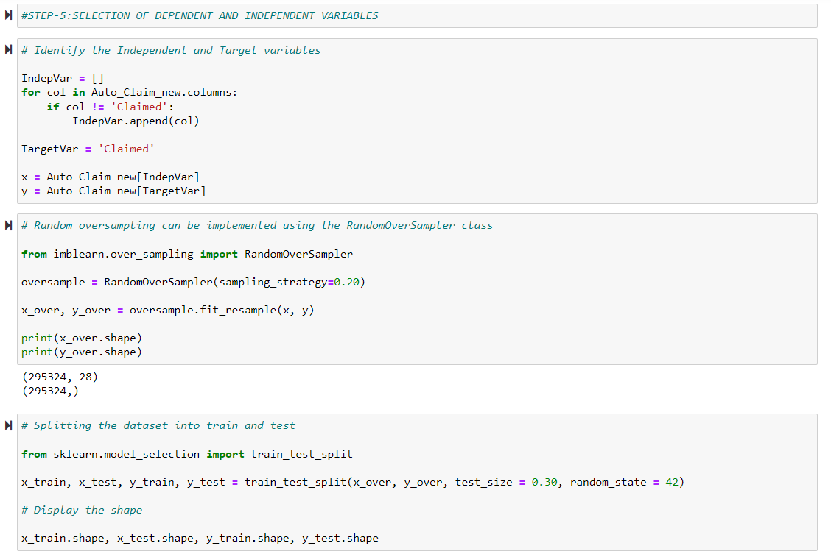

### UNDER SAMPLING:

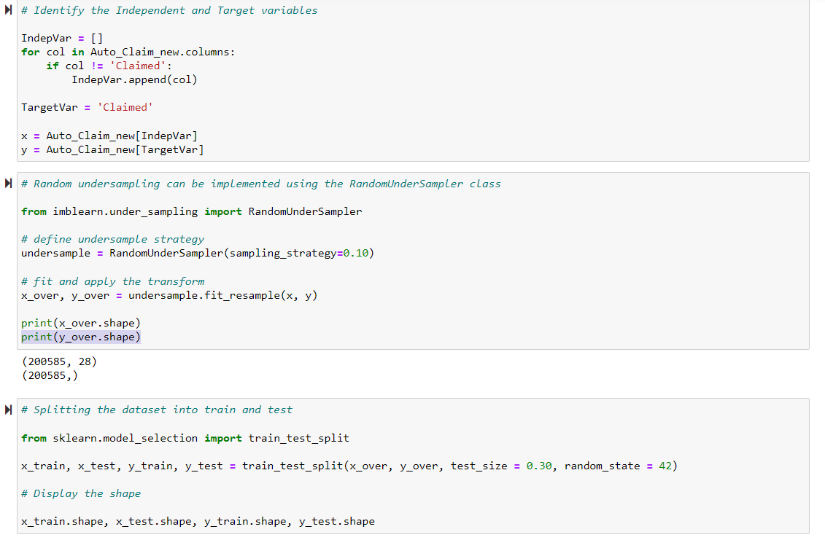

### LOGISTIC REGRESSION Python Code:

#LOGISTIC REGRESSION:

# To build the decision tree model with random sampling

from sklearn.linear_model import LogisticRegression

# Create an object for LR model

ModelLR = LogisticRegression()

# Train the model with training data

ModelLR = ModelLR.fit(x_train,y_train)

# Predict the model with test data set

y_pred = ModelLR.predict(x_test)

# confusion matrix in sklearn

from sklearn.metrics import confusion_matrix

from sklearn.metrics import classification_report

# actual values

actual = y_test

# predicted values

predicted = y_pred

# confusion matrix

matrix = confusion_matrix(actual,predicted, labels=[1,0],sample_weight=None, normalize=None)

print('Confusion matrix : \n', matrix)

# outcome values order in sklearn

tp, fn, fp, tn = confusion_matrix(actual,predicted,labels=[1,0]).reshape(-1)

print('Outcome values : \n', tp, fn, fp, tn)

# classification report for precision, recall f1-score and accuracy

C_Report = classification_report(actual,predicted,labels=[1,0])

print('Classification report : \n', C_Report)

# calculating the metrics

sensitivity = round(tp/(tp+fn), 3);

specificity = round(tn/(tn+fp), 3);

accuracy = round((tp+tn)/(tp+fp+tn+fn), 3);

balanced_accuracy = round((sensitivity+specificity)/2, 3);

precision = round(tp/(tp+fp), 3);

f1Score = round((2*tp/(2*tp + fp + fn)), 3);

# Matthews Correlation Coefficient (MCC). Range of values of MCC lie between -1 to +1.

# A model with a score of +1 is a perfect model and -1 is a poor model

from math import sqrt

mx = (tp+fp) * (tp+fn) * (tn+fp) * (tn+fn)

MCC = round(((tp * tn) - (fp * fn)) / sqrt(mx), 3)

print('Accuracy :', round(accuracy*100, 2),'%')

print('Precision :', round(precision*100, 2),'%')

print('Recall :', round(sensitivity*100,2), '%')

print('F1 Score :', f1Score)

print('Specificity or True Negative Rate :', round(specificity*100,2), '%' )

print('Balanced Accuracy :', round(balanced_accuracy*100, 2),'%')

print('MCC :', MCC)

# Area under ROC curve

from sklearn.metrics import roc_curve, roc_auc_score

print('roc_auc_score:', round(roc_auc_score(actual, predicted), 3))

# ROC Curve

from sklearn.metrics import roc_auc_score

from sklearn.metrics import roc_curve

model_roc_auc = roc_auc_score(actual, predicted)

fpr, tpr, thresholds = roc_curve(actual, ModelLR.predict_proba(x_test)[:,1])

plt.figure()

# plt.plot(fpr, tpr, label='Logistic Regression (area = %0.2f)' % logit_roc_auc)

plt.plot(fpr, tpr, label= 'Classification Model' % model_roc_auc)

plt.plot([0, 1], [0, 1],'r--')

plt.xlim([0.0, 1.0])

plt.ylim([0.0, 1.05])

plt.xlabel('False Positive Rate')

plt.ylabel('True Positive Rate')

plt.title('Receiver operating characteristic')

plt.legend(loc="lower right")

#plt.savefig('Log_ROC')

plt.show()

print('-----------------------------------------------------------------------------------------------------')

#----------------------------------------------------------------------------------------------------------

new_row = {'Model Name' :ModelLR ,

'True_Positive': tp,

'False_Negative': fn,

'False_Positive': fp,

'True_Negative': tn,

'Accuracy' : accuracy,

'Precision' : precision,

'Recall' : sensitivity,

'F1 Score' : f1Score,

'Specificity' : specificity,

'MCC': 'MCC',

'ROC_AUC_Score':roc_auc_score(actual, predicted),

'Balanced Accuracy':balanced_accuracy}

CSResults = CSResults.append(new_row, ignore_index=True)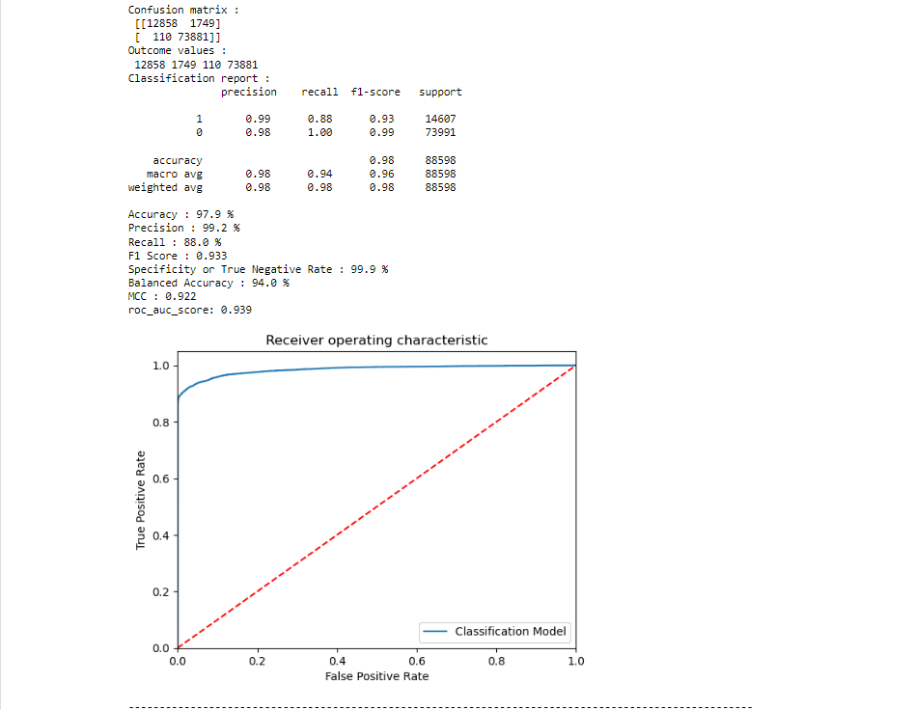

### DECISION TREE Python Code:

#DECISION TREE CLASSIFIER ALGORITHAM

# To build the 'Decision Tree' model with random sampling

from sklearn.tree import DecisionTreeClassifier

# Create an object for model

ModelDT = DecisionTreeClassifier()

#ModelDT = DecisionTreeClassifier(criterion='gini', splitter='best', max_depth=None, min_samples_split=2,

# min_samples_leaf=1, min_weight_fraction_leaf=0.0, max_features=None,

# random_state=None, max_leaf_nodes=None, min_impurity_decrease=0.0,

# class_weight=None, ccp_alpha=0.0)

# Train the model with train data

ModelDT.fit(x_train,y_train)

# Predict the model with test data set

y_pred = ModelDT.predict(x_test)

y_pred_prob = ModelDT.predict_proba(x_test)

# Confusion matrix in sklearn

from sklearn.metrics import confusion_matrix

from sklearn.metrics import classification_report

# actual values

actual = y_test

# predicted values

predicted = y_pred

# confusion matrix

matrix = confusion_matrix(actual,predicted, labels=[1,0],sample_weight=None, normalize=None)

print('Confusion matrix : \n', matrix)

# outcome values order in sklearn

tp, fn, fp, tn = confusion_matrix(actual,predicted,labels=[1,0]).reshape(-1)

print('Outcome values : \n', tp, fn, fp, tn)

# classification report for precision, recall f1-score and accuracy

C_Report = classification_report(actual,predicted,labels=[1,0])

print('Classification report : \n', C_Report)

# calculating the metrics

sensitivity = round(tp/(tp+fn), 3);

specificity = round(tn/(tn+fp), 3);

accuracy = round((tp+tn)/(tp+fp+tn+fn), 3);

balanced_accuracy = round((sensitivity+specificity)/2, 3);

precision = round(tp/(tp+fp), 3);

f1Score = round((2*tp/(2*tp + fp + fn)), 3);

# Matthews Correlation Coefficient (MCC). Range of values of MCC lie between -1 to +1.

# A model with a score of +1 is a perfect model and -1 is a poor model

from math import sqrt

mx = (tp+fp) * (tp+fn) * (tn+fp) * (tn+fn)

MCC = round(((tp * tn) - (fp * fn)) / sqrt(mx), 3)

print('Accuracy :', round(accuracy*100, 2),'%')

print('Precision :', round(precision*100, 2),'%')

print('Recall :', round(sensitivity*100,2), '%')

print('F1 Score :', f1Score)

print('Specificity or True Negative Rate :', round(specificity*100,2), '%' )

print('Balanced Accuracy :', round(balanced_accuracy*100, 2),'%')

print('MCC :', MCC)

# Area under ROC curve

from sklearn.metrics import roc_curve, roc_auc_score

print('roc_auc_score:', round(roc_auc_score(actual, predicted), 3))

# ROC Curve

from sklearn.metrics import roc_auc_score

from sklearn.metrics import roc_curve

model_roc_auc = roc_auc_score(actual, predicted)

fpr, tpr, thresholds = roc_curve(actual, ModelDT.predict_proba(x_test)[:,1])

plt.figure()

# plt.plot(fpr, tpr, label='Logistic Regression (area = %0.2f)' % logit_roc_auc)

plt.plot(fpr, tpr, label= 'Classification Model' % model_roc_auc)

plt.plot([0, 1], [0, 1],'r--')

plt.xlim([0.0, 1.0])

plt.ylim([0.0, 1.05])

plt.xlabel('False Positive Rate')

plt.ylabel('True Positive Rate')

plt.title('Receiver operating characteristic')

plt.legend(loc="lower right")

plt.show()

print('-----------------------------------------------------------------------------------------------------')

#----------------------------------------------------------------------------------------------------------

new_row = {'Model Name' : ModelDT,

'True_Positive': tp,

'False_Negative': fn,

'False_Positive': fp,

'True_Negative': tn,

'Accuracy' : accuracy,

'Precision' : precision,

'Recall' : sensitivity,

'F1 Score' : f1Score,

'Specificity' : specificity,

'MCC': 'MCC',

'ROC_AUC_Score':roc_auc_score(actual, predicted),

'Balanced Accuracy':balanced_accuracy}

CSResults = CSResults.append(new_row, ignore_index=True)

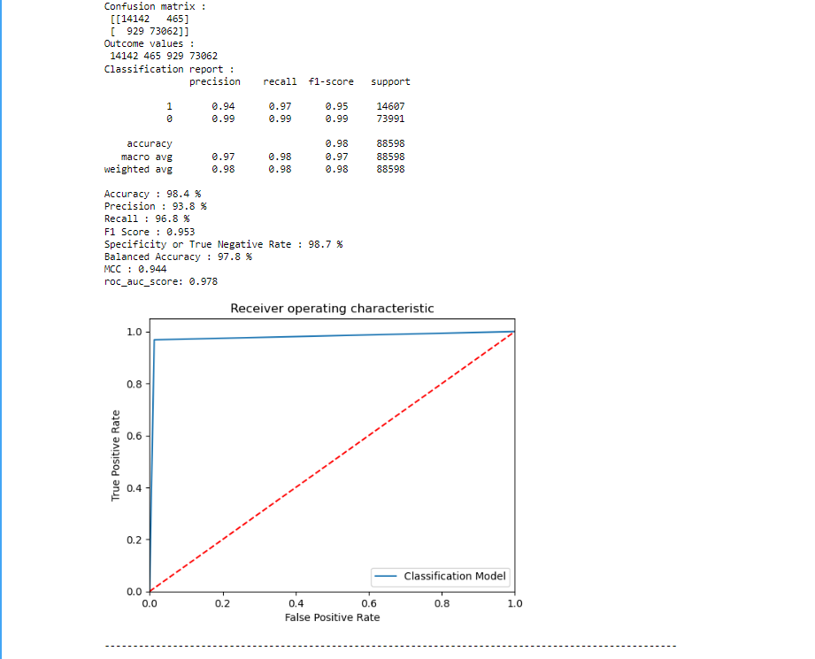

### Random Forest Python Code:

#RANDOM FOREST:

# To build the 'Random Forest' model with random sampling

from sklearn.ensemble import RandomForestClassifier

# Create model object

ModelRF = RandomForestClassifier()

#ModelRF = RandomForestClassifier(n_estimators=100, criterion='gini', max_depth=None, min_samples_split=2,

# min_samples_leaf=1, min_weight_fraction_leaf=0.0, max_features='sqrt',

# max_leaf_nodes=None, min_impurity_decrease=0.0, bootstrap=True, oob_score=False,

# n_jobs=None, random_state=None, verbose=0, warm_start=False, class_weight=None,

# ccp_alpha=0.0, max_samples=None)

# Train the model with train data

ModelRF.fit(x_train,y_train)

# Predict the model with test data set

y_pred = ModelRF.predict(x_test)

y_pred_prob = ModelRF.predict_proba(x_test)

# Confusion matrix in sklearn

from sklearn.metrics import confusion_matrix

from sklearn.metrics import classification_report

# actual values

actual = y_test

# predicted values

predicted = y_pred

# confusion matrix

matrix = confusion_matrix(actual,predicted, labels=[1,0],sample_weight=None, normalize=None)

print('Confusion matrix : \n', matrix)

# outcome values order in sklearn

tp, fn, fp, tn = confusion_matrix(actual,predicted,labels=[1,0]).reshape(-1)

print('Outcome values : \n', tp, fn, fp, tn)

# classification report for precision, recall f1-score and accuracy

C_Report = classification_report(actual,predicted,labels=[1,0])

print('Classification report : \n', C_Report)

# calculating the metrics

sensitivity = round(tp/(tp+fn), 3);

specificity = round(tn/(tn+fp), 3);

accuracy = round((tp+tn)/(tp+fp+tn+fn), 3);

balanced_accuracy = round((sensitivity+specificity)/2, 3);

precision = round(tp/(tp+fp), 3);

f1Score = round((2*tp/(2*tp + fp + fn)), 3);

# Matthews Correlation Coefficient (MCC). Range of values of MCC lie between -1 to +1.

# A model with a score of +1 is a perfect model and -1 is a poor model

from math import sqrt

mx = (tp+fp) * (tp+fn) * (tn+fp) * (tn+fn)

MCC = round(((tp * tn) - (fp * fn)) / sqrt(mx), 3)

print('Accuracy :', round(accuracy*100, 2),'%')

print('Precision :', round(precision*100, 2),'%')

print('Recall :', round(sensitivity*100,2), '%')

print('F1 Score :', f1Score)

print('Specificity or True Negative Rate :', round(specificity*100,2), '%' )

print('Balanced Accuracy :', round(balanced_accuracy*100, 2),'%')

print('MCC :', MCC)

# Area under ROC curve

from sklearn.metrics import roc_curve, roc_auc_score

print('roc_auc_score:', round(roc_auc_score(actual, predicted), 3))

# ROC Curve

from sklearn.metrics import roc_auc_score

from sklearn.metrics import roc_curve

model_roc_auc = roc_auc_score(actual, predicted)

fpr, tpr, thresholds = roc_curve(actual, ModelRF.predict_proba(x_test)[:,1])

plt.figure()

#--------------------------------------------------------------------

plt.plot(fpr, tpr, label= 'Classification Model' % model_roc_auc)

plt.plot([0, 1], [0, 1],'r--')

plt.xlim([0.0, 1.0])

plt.ylim([0.0, 1.05])

plt.xlabel('False Positive Rate')

plt.ylabel('True Positive Rate')

plt.title('Receiver operating characteristic')

plt.legend(loc="lower right")

#plt.savefig('Log_ROC')

plt.show()

print('-----------------------------------------------------------------------------------------------------')

#----------------------------------------------------------------------------------------------------------

new_row = {'Model Name' : ModelRF,

'True_Positive': tp,

'False_Negative': fn,

'False_Positive': fp,

'True_Negative': tn,

'Accuracy' : accuracy,

'Precision' : precision,

'Recall' : sensitivity,

'F1 Score' : f1Score,

'Specificity' : specificity,

'MCC': 'MCC',

'ROC_AUC_Score':roc_auc_score(actual, predicted),

'Balanced Accuracy':balanced_accuracy}

CSResults = CSResults.append(new_row, ignore_index=True)

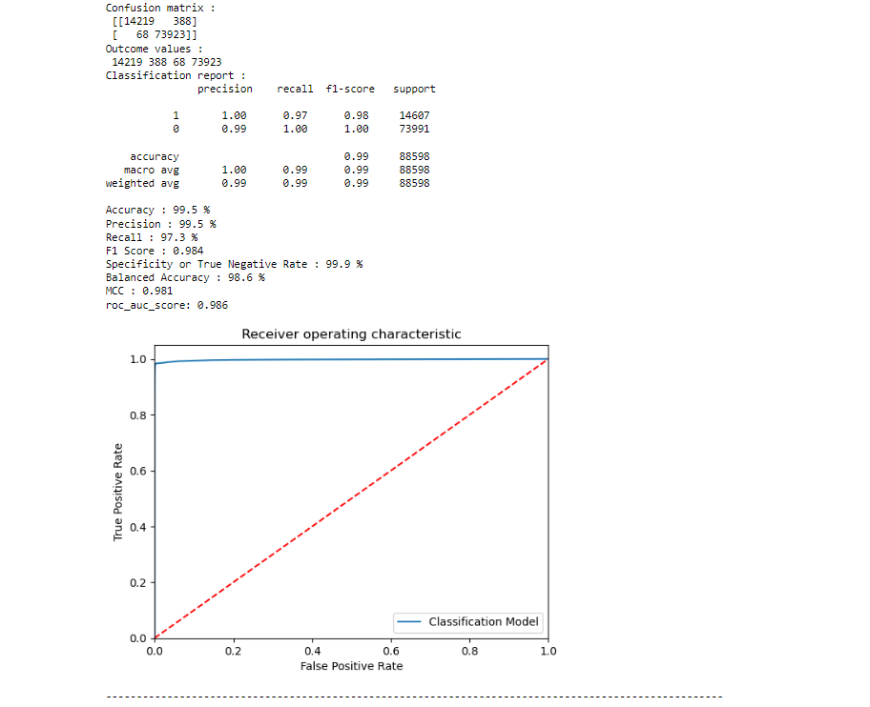

### Extra Trees Python code:

#EXTRA TREE CLASSIFIER

# To build the 'Random Forest' model with random sampling

from sklearn.ensemble import ExtraTreesClassifier

# Create model object

ModelET = ExtraTreesClassifier()

# Evalution matrix for the algorithm

MM = [ModelET]

for models in MM:

# Train the model training dataset

models.fit(x_train, y_train)

# Prediction the model with test dataset

y_pred = models.predict(x_test)

y_pred_prob = models.predict_proba(x_test)

# Print the model name

print('Model Name: ', models)

# confusion matrix in sklearn

from sklearn.metrics import confusion_matrix

from sklearn.metrics import classification_report

# actual values

actual = y_test

# predicted values

predicted = y_pred

# confusion matrix

matrix = confusion_matrix(actual,predicted, labels=[1,0],sample_weight=None, normalize=None)

print('Confusion matrix : \n', matrix)

# outcome values order in sklearn

tp, fn, fp, tn = confusion_matrix(actual,predicted,labels=[1,0]).reshape(-1)

print('Outcome values : \n', tp, fn, fp, tn)

# classification report for precision, recall f1-score and accuracy

C_Report = classification_report(actual,predicted,labels=[1,0])

print('Classification report : \n', C_Report)

# calculating the metrics

sensitivity = round(tp/(tp+fn), 3);

specificity = round(tn/(tn+fp), 3);

accuracy = round((tp+tn)/(tp+fp+tn+fn), 3);

balanced_accuracy = round((sensitivity+specificity)/2, 3);

precision = round(tp/(tp+fp), 3);

f1Score = round((2*tp/(2*tp + fp + fn)), 3);

# Matthews Correlation Coefficient (MCC). Range of values of MCC lie between -1 to +1.

# A model with a score of +1 is a perfect model and -1 is a poor model

#from math import sqrt

#mx = (tp+fp) * (tp+fn) * (tn+fp) * (tn+fn)

MCC = round(((tp * tn) - (fp * fn)) / sqrt(mx), 3)

print('Accuracy :', round(accuracy*100, 2),'%')

print('Precision :', round(precision*100, 2),'%')

print('Recall :', round(sensitivity*100,2), '%')

print('F1 Score :', f1Score)

print('Specificity or True Negative Rate :', round(specificity*100,2), '%' )

print('Balanced Accuracy :', round(balanced_accuracy*100, 2),'%')

print('MCC :', MCC)

# Area under ROC curve

from sklearn.metrics import roc_curve, roc_auc_score

print('roc_auc_score:', round(roc_auc_score(actual, predicted), 3))

# ROC Curve

from sklearn.metrics import roc_auc_score

from sklearn.metrics import roc_curve

Model_roc_auc = roc_auc_score(actual, predicted)

fpr, tpr, thresholds = roc_curve(actual, models.predict_proba(x_test)[:,1])

plt.figure()

#

plt.plot(fpr, tpr, label= 'Classification Model' % Model_roc_auc)

plt.plot([0, 1], [0, 1],'r--')

plt.xlim([0.0, 1.0])

plt.ylim([0.0, 1.05])

plt.xlabel('False Positive Rate')

plt.ylabel('True Positive Rate')

plt.title('Receiver operating characteristic')

plt.legend(loc="lower right")

plt.savefig('Log_ROC')

plt.show()

print('-----------------------------------------------------------------------------------------------------')

#----------------------------------------------------------------------------------------------------------

new_row = {'Model Name' : models,

'True_Positive': tp,

'False_Negative': fn,

'False_Positive': fp,

'True_Negative': tn,

'Accuracy' : accuracy,

'Precision' : precision,

'Recall' : sensitivity,

'F1 Score' : f1Score,

'Specificity' : specificity,

'MCC': 'MCC',

'ROC_AUC_Score':roc_auc_score(actual, predicted),

'Balanced Accuracy':balanced_accuracy}

CSResults = CSResults.append(new_row, ignore_index=True)

#----------------------------------------------------------------------------------------------------------

### KNN CLASSIFIER Python Code:

#### KNeighborsClassifier performing to find the best suitable k value:

# Initialise an array that stores the Accuracy

from sklearn.neighbors import KNeighborsClassifier

from sklearn.metrics import classification_report, confusion_matrix, accuracy_score

import sklearn.metrics as metrics

from sklearn.metrics import roc_curve, roc_auc_score

accuracy = []

for a in range(1, 11, 1):

k = a

# Build the model

ModelKNN = KNeighborsClassifier(n_neighbors=k)

# Train the model

ModelKNN.fit(x_train, y_train)

# Predict the model

y_pred = ModelKNN.predict(x_test)

y_pred_prob = ModelKNN.predict_proba(x_test)

print('KNN_K_value = ', a)

# Print the model name

print('Model Name: ', ModelKNN)

# confusion matrix in sklearn

from sklearn.metrics import confusion_matrix

from sklearn.metrics import classification_report

# actual values

actual = y_test

# predicted values

predicted = y_pred

# confusion matrix

matrix = confusion_matrix(actual,predicted, labels=[1,0],sample_weight=None, normalize=None)

print('Confusion matrix : \n', matrix)

# outcome values order in sklearn

tp, fn, fp, tn = confusion_matrix(actual,predicted,labels=[1,0]).reshape(-1)

print('Outcome values : \n', tp, fn, fp, tn)

# classification report for precision, recall f1-score and accuracy

C_Report = classification_report(actual,predicted,labels=[1,0])

print('Classification report : \n', C_Report)

# calculating the metrics

sensitivity = round(tp/(tp+fn), 3);

specificity = round(tn/(tn+fp), 3);

accuracy = round((tp+tn)/(tp+fp+tn+fn), 3);

balanced_accuracy = round((sensitivity+specificity)/2, 3);

precision = round(tp/(tp+fp), 3);

f1Score = round((2*tp/(2*tp + fp + fn)), 3);

# Matthews Correlation Coefficient (MCC). Range of values of MCC lie between -1 to +1.

# A model with a score of +1 is a perfect model and -1 is a poor model

from math import sqrt

mx = (tp+fp) * (tp+fn) * (tn+fp) * (tn+fn)

MCC = round(((tp * tn) - (fp * fn)) / sqrt(mx), 3)

print('Accuracy :', round(accuracy*100, 2),'%')

print('Precision :', round(precision*100, 2),'%')

print('Recall :', round(sensitivity*100,2), '%')

print('F1 Score :', f1Score)

print('Specificity or True Negative Rate :', round(specificity*100,2), '%' )

print('Balanced Accuracy :', round(balanced_accuracy*100, 2),'%')

print('MCC :', MCC)

# Area under ROC curve

from sklearn.metrics import roc_curve, roc_auc_score

print('roc_auc_score:', round(roc_auc_score(actual, predicted), 3))

# ROC Curve

from sklearn.metrics import roc_auc_score

from sklearn.metrics import roc_curve

logit_roc_auc = roc_auc_score(actual, predicted)

fpr, tpr, thresholds = roc_curve(actual, ModelKNN.predict_proba(x_test)[:,1])

plt.figure()

# plt.plot(fpr, tpr, label='Logistic Regression (area = %0.2f)' % logit_roc_auc)

plt.plot(fpr, tpr, label= 'Classification Model' % logit_roc_auc)

plt.plot([0, 1], [0, 1],'r--')

plt.xlim([0.0, 1.0])

plt.ylim([0.0, 1.05])

plt.xlabel('False Positive Rate')

plt.ylabel('True Positive Rate')

plt.title('Receiver operating characteristic')

plt.legend(loc="lower right")

plt.savefig('Log_ROC')

plt.show()

#--------------------------------------------------------tp, fn, fp, tn

new_row = {'Model Name' : ModelKNN,

'KNN K Value' : a,

'True_Positive' : tp,

'False_Negative' : fn,

'False_Positive' : fp,

'True_Negative' : tn,

'Accuracy' : accuracy,

'Precision' : precision,

'Recall' : sensitivity,

'F1 Score' : f1Score,

'Specificity' : specificity,

'MCC': MCC,

'ROC_AUC_Score': roc_auc_score(actual, predicted),

'Balanced Accuracy': balanced_accuracy}

KNNResults = KNNResults.append(new_row, ignore_index=True)

#--------------------------------------------------------

print('-----------------------------------------------------------------------------------------------------')

#### AFTER SELECTING VALUE OF K FOR KNN CLASSIFIER(Python Code) :

# Initialise an array that stores the Accuracy

from sklearn.neighbors import KNeighborsClassifier

from sklearn.metrics import classification_report, confusion_matrix, accuracy_score

import sklearn.metrics as metrics

from sklearn.metrics import roc_curve, roc_auc_score

accuracy = []

#for a in range(1, 11, 1):

k = a = 5

# Build the model

ModelKNN = KNeighborsClassifier(n_neighbors=k)

# Train the model

ModelKNN.fit(x_train, y_train)

# Predict the model

y_pred = ModelKNN.predict(x_test)

y_pred_prob = ModelKNN.predict_proba(x_test)

print('KNN_K_value = ', a)

# Print the model name

print('Model Name: ', ModelKNN)

# confusion matrix in sklearn

from sklearn.metrics import confusion_matrix

from sklearn.metrics import classification_report

# actual values

actual = y_test

# predicted values

predicted = y_pred

# confusion matrix

matrix = confusion_matrix(actual,predicted, labels=[1,0],sample_weight=None, normalize=None)

print('Confusion matrix : \n', matrix)

# outcome values order in sklearn

tp, fn, fp, tn = confusion_matrix(actual,predicted,labels=[1,0]).reshape(-1)

print('Outcome values : \n', tp, fn, fp, tn)

# classification report for precision, recall f1-score and accuracy

C_Report = classification_report(actual,predicted,labels=[1,0])

print('Classification report : \n', C_Report)

# calculating the metrics

sensitivity = round(tp/(tp+fn), 3);

specificity = round(tn/(tn+fp), 3);

accuracy = round((tp+tn)/(tp+fp+tn+fn), 3);

balanced_accuracy = round((sensitivity+specificity)/2, 3);

precision = round(tp/(tp+fp), 3);

f1Score = round((2*tp/(2*tp + fp + fn)), 3);

# Matthews Correlation Coefficient (MCC). Range of values of MCC lie between -1 to +1.

# A model with a score of +1 is a perfect model and -1 is a poor model

from math import sqrt

mx = (tp+fp) * (tp+fn) * (tn+fp) * (tn+fn)

MCC = round(((tp * tn) - (fp * fn)) / sqrt(mx), 3)

print('Accuracy :', round(accuracy*100, 2),'%')

print('Precision :', round(precision*100, 2),'%')

print('Recall :', round(sensitivity*100,2), '%')

print('F1 Score :', f1Score)

print('Specificity or True Negative Rate :', round(specificity*100,2), '%' )

print('Balanced Accuracy :', round(balanced_accuracy*100, 2),'%')

print('MCC :', MCC)

# Area under ROC curve

from sklearn.metrics import roc_curve, roc_auc_score

print('roc_auc_score:', round(roc_auc_score(actual, predicted), 3))

# ROC Curve

from sklearn.metrics import roc_auc_score

from sklearn.metrics import roc_curve

logit_roc_auc = roc_auc_score(actual, predicted)

fpr, tpr, thresholds = roc_curve(actual, ModelKNN.predict_proba(x_test)[:,1])

plt.figure()

# plt.plot(fpr, tpr, label='Logistic Regression (area = %0.2f)' % logit_roc_auc)

plt.plot(fpr, tpr, label= 'Classification Model' % logit_roc_auc)

plt.plot([0, 1], [0, 1],'r--')

plt.xlim([0.0, 1.0])

plt.ylim([0.0, 1.05])

plt.xlabel('False Positive Rate')

plt.ylabel('True Positive Rate')

plt.title('Receiver operating characteristic')

plt.legend(loc="lower right")

plt.savefig('Log_ROC')

plt.show()

#--------------------------------------------------------tp, fn, fp, tn

new_row = {'Model Name' : ModelKNN,

'KNN K Value' : a,

'True_Positive' : tp,

'False_Negative' : fn,

'False_Positive' : fp,

'True_Negative' : tn,

'Accuracy' : accuracy,

'Precision' : precision,

'Recall' : sensitivity,

'F1 Score' : f1Score,

'Specificity' : specificity,

'MCC': MCC,

'ROC_AUC_Score': roc_auc_score(actual, predicted),

'Balanced Accuracy': balanced_accuracy}

CSResults = CSResults.append(new_row, ignore_index=True)

#--------------------------------------------------------

print('-----------------------------------------------------------------------------------------------------')

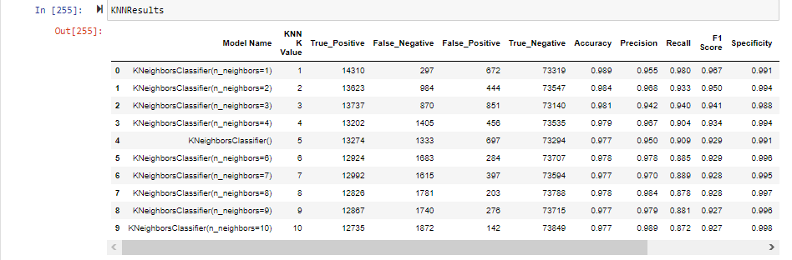

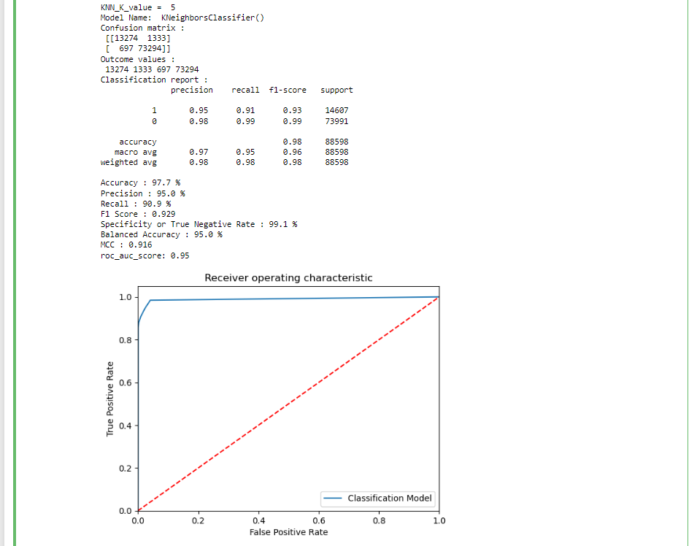

### SVM Python Code:

As SVM is highly complex and as our data set is very large in size we take only 10% of the data set is taken and did analysis and after analysis we consider the result and apply to the whole data set.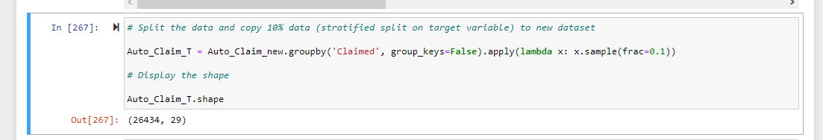

#### SVM Calssification models and compare the results:

# Build the all types of SVM Calssification models and compare the results

from sklearn.svm import SVC

# Create objects of classification algorithm with default hyper-parameters

SVMLIN = SVC(C=1.0, kernel='linear', degree=3, gamma='scale', coef0=0.0, shrinking=True,

probability=True, tol=0.001, cache_size=200, class_weight=None, verbose=False,

max_iter=- 1, decision_function_shape='ovr', break_ties=False, random_state=None)

SVMPLY = SVC(kernel='poly', degree=2, probability=True)

SVMGSN = SVC(kernel='rbf', random_state = 42, class_weight='balanced', probability=True)

SVMSIG = SVC(kernel='sigmoid', random_state = 42, class_weight='balanced', probability=True)

# Evalution matrix for all the algorithms

MM = [SVMLIN, SVMPLY, SVMGSN, SVMSIG]

for models in MM:

# Fit the model

models.fit(x_train, y_train)

# Prediction

y_pred = models.predict(x_test)

y_pred_prob = models.predict_proba(x_test)

# Print the model name

print('Model Name: ', models)

# confusion matrix in sklearn

from sklearn.metrics import confusion_matrix

from sklearn.metrics import classification_report

# actual values

actual = y_test

# predicted values

predicted = y_pred

# confusion matrix

matrix = confusion_matrix(actual,predicted, labels=[1,0],sample_weight=None, normalize=None)

print('Confusion matrix : \n', matrix)

# outcome values order in sklearn

tp, fn, fp, tn = confusion_matrix(actual,predicted,labels=[1,0]).reshape(-1)

print('Outcome values : \n', tp, fn, fp, tn)

# classification report for precision, recall f1-score and accuracy

C_Report = classification_report(actual,predicted,labels=[1,0])

print('Classification report : \n', C_Report)

# calculating the metrics

sensitivity = round(tp/(tp+fn), 3);

specificity = round(tn/(tn+fp), 3);

accuracy = round((tp+tn)/(tp+fp+tn+fn), 3);

balanced_accuracy = round((sensitivity+specificity)/2, 3);

precision = round(tp/(tp+fp), 3);

f1Score = round((2*tp/(2*tp + fp + fn)), 3);

# Matthews Correlation Coefficient (MCC). Range of values of MCC lie between -1 to +1.

# A model with a score of +1 is a perfect model and -1 is a poor model

from math import sqrt

mx = (tp+fp) * (tp+fn) * (tn+fp) * (tn+fn)

MCC = round(((tp * tn) - (fp * fn)) / sqrt(mx), 3)

print('Accuracy :', round(accuracy*100, 2),'%')

print('Precision :', round(precision*100, 2),'%')

print('Recall :', round(sensitivity*100,2), '%')

print('F1 Score :', f1Score)

print('Specificity or True Negative Rate :', round(specificity*100,2), '%')

print('Balanced Accuracy :', round(balanced_accuracy*100, 2),'%')

print('MCC :', MCC)

# Area under ROC curve

from sklearn.metrics import roc_curve, roc_auc_score

print('roc_auc_score:', round(roc_auc_score(actual, predicted), 3))

# ROC Curve

from sklearn.metrics import roc_auc_score

from sklearn.metrics import roc_curve

model_roc_auc = roc_auc_score(actual, predicted)

fpr, tpr, thresholds = roc_curve(actual, models.predict_proba(x_test)[:,1])

plt.figure()

# plt.plot

plt.plot(fpr, tpr, label= 'Classification Model' % model_roc_auc)

plt.plot([0, 1], [0, 1],'r--')

plt.xlim([0.0, 1.0])

plt.ylim([0.0, 1.05])

plt.xlabel('False Positive Rate')

plt.ylabel('True Positive Rate')

plt.title('Receiver operating characteristic')

plt.legend(loc="lower right")

plt.savefig('Log_ROC')

plt.show()

print('-----------------------------------------------------------------------------------------------------')

#---

new_row = {'Model Name' : models,

'True_Positive' : tp,

'False_Negative' : fn,

'False_Positive' : fp,

'True_Negative' : tn,

'Accuracy' : accuracy,

'Precision' : precision,

'Recall' : sensitivity,

'F1 Score' : f1Score,

'Specificity' : specificity,

'MCC':MCC,

'ROC_AUC_Score':roc_auc_score(actual, predicted),

'Balanced Accuracy':balanced_accuracy}

EMResults = EMResults.append(new_row, ignore_index=True)

#---

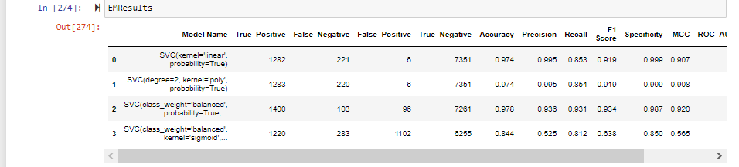

#### BEST SVM ALGORITHM SELECTION AFTER COMAPRISON OF ALL SVM ALGORITHMS:

Out of all svm models we are getting the best results for SVM-Polynomial Kernel

# Training the SVM algorithm

from sklearn.svm import SVC

CustPrb_TSVMPoly = SVC(kernel='poly', degree=2, probability=True)

# Train the model

CustPrb_TSVMPoly.fit(x_train, y_train)

# Predict the model with test data set

y_pred = CustPrb_TSVMPoly.predict(x_test)

y_pred_prob = CustPrb_TSVMPoly.predict_proba(x_test)

# Print the model name

print('Model Name: ', "SVM - Polynominal")

# Confusion matrix in sklearn

from sklearn.metrics import confusion_matrix

from sklearn.metrics import classification_report

# actual values

actual = y_test

# predicted values

predicted = y_pred

# confusion matrix

matrix = confusion_matrix(actual,predicted, labels=[1,0],sample_weight=None, normalize=None)

print('Confusion matrix : \n', matrix)

# outcome values order in sklearn

tp, fn, fp, tn = confusion_matrix(actual,predicted,labels=[1,0]).reshape(-1)

print('Outcome values : \n', tp, fn, fp, tn)

# classification report for precision, recall f1-score and accuracy

C_Report = classification_report(actual,predicted,labels=[1,0])

print('Classification report : \n', C_Report)

# calculating the metrics

sensitivity = round(tp/(tp+fn), 3);

specificity = round(tn/(tn+fp), 3);

accuracy = round((tp+tn)/(tp+fp+tn+fn), 3);

balanced_accuracy = round((sensitivity+specificity)/2, 3);

precision = round(tp/(tp+fp), 3);

f1Score = round((2*tp/(2*tp + fp + fn)), 3);

# Matthews Correlation Coefficient (MCC). Range of values of MCC lie between -1 to +1.

# A model with a score of +1 is a perfect model and -1 is a poor model

from math import sqrt

mx = (tp+fp) * (tp+fn) * (tn+fp) * (tn+fn)

MCC = round(((tp * tn) - (fp * fn)) / sqrt(mx), 3)

print('Accuracy :', round(accuracy*100, 2),'%')

print('Precision :', round(precision*100, 2),'%')

print('Recall :', round(sensitivity*100,2), '%')

print('F1 Score :', f1Score)

print('Specificity or True Negative Rate :', round(specificity*100,2), '%' )

print('Balanced Accuracy :', round(balanced_accuracy*100, 2),'%')

print('MCC :', MCC)

# Area under ROC curve

from sklearn.metrics import roc_curve, roc_auc_score

print('roc_auc_score:', round(roc_auc_score(y_test, y_pred), 3))

# ROC Curve

from sklearn.metrics import roc_auc_score

from sklearn.metrics import roc_curve

logit_roc_auc = roc_auc_score(y_test, y_pred)

fpr, tpr, thresholds = roc_curve(y_test,CustPrb_TSVMPoly.predict_proba(x_test)[:,1])

plt.figure()

# plt.plot

plt.plot(fpr, tpr, label= 'Classification Model' % logit_roc_auc)

plt.plot([0, 1], [0, 1],'r--')

plt.xlim([0.0, 1.0])

plt.ylim([0.0, 1.05])

plt.xlabel('False Positive Rate')

plt.ylabel('True Positive Rate')

plt.title('Receiver operating characteristic')

plt.legend(loc="lower right")

plt.savefig('Log_ROC')

plt.show()

print('-----------------------------------------------------------------------------------------------------')

#---

new_row = {'Model Name' : "SVM - Polynominal",

'True_Positive' : tp,

'False_Negative' : fn,

'False_Positive' : fp,

'True_Negative' : tn,

'Accuracy' : accuracy,

'Precision' : precision,

'Recall' : sensitivity,

'F1 Score' : f1Score,

'Specificity' : specificity,

'MCC':MCC,

'ROC_AUC_Score':roc_auc_score(actual, predicted),

'Balanced Accuracy':balanced_accuracy}

CSResults = CSResults.append(new_row, ignore_index=True)

#---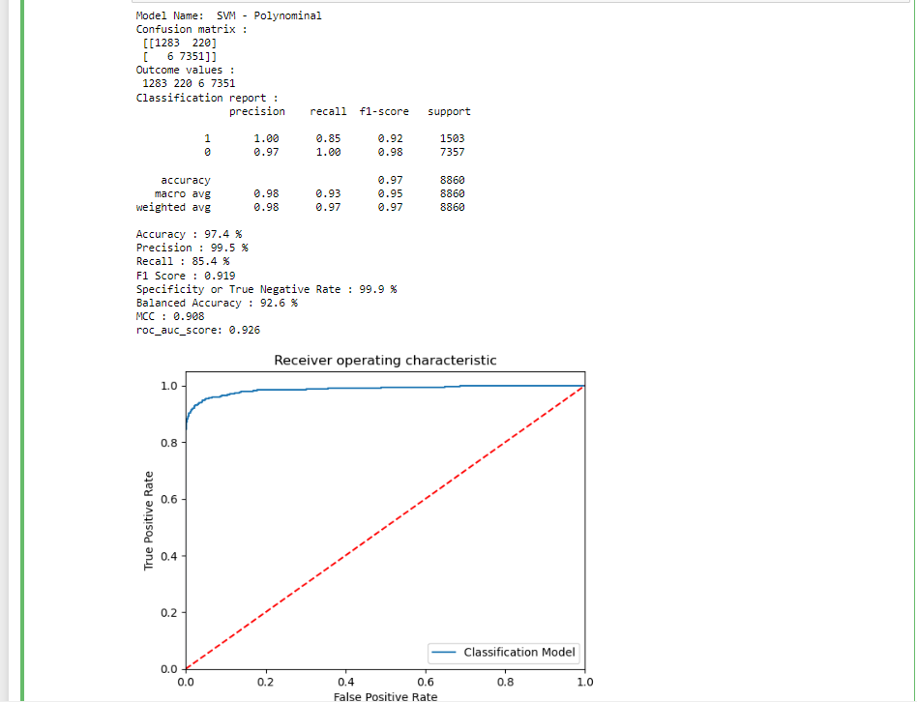

### NAIVE BAYES MODEL(GaussianNB):

#NAIVE BAES MODEL

# Training the Naive Bayes model (GaussianNB) on the Training set

from sklearn.naive_bayes import GaussianNB

modelGNB = GaussianNB(priors=None, var_smoothing=1e-09)

# Fit the model with train data

modelGNB.fit(x_train,y_train)

# Predict the model with test data set

y_pred = modelGNB.predict(x_test)

y_pred_prob = modelGNB.predict_proba(x_test)

# Confusion matrix in sklearn

from sklearn.metrics import confusion_matrix

from sklearn.metrics import classification_report

# actual values

actual = y_test

# predicted values

predicted = y_pred

# confusion matrix

matrix = confusion_matrix(actual,predicted, labels=[1,0],sample_weight=None, normalize=None)

print('Confusion matrix : \n', matrix)

# outcome values order in sklearn

tp, fn, fp, tn = confusion_matrix(actual,predicted,labels=[1,0]).reshape(-1)

print('Outcome values : \n', tp, fn, fp, tn)

# classification report for precision, recall f1-score and accuracy

C_Report = classification_report(actual,predicted,labels=[1,0])

print('Classification report : \n', C_Report)

# calculating the metrics

sensitivity = round(tp/(tp+fn), 3);

specificity = round(tn/(tn+fp), 3);

accuracy = round((tp+tn)/(tp+fp+tn+fn), 3);

balanced_accuracy = round((sensitivity+specificity)/2, 3);

precision = round(tp/(tp+fp), 3);

f1Score = round((2*tp/(2*tp + fp + fn)), 3);

# Matthews Correlation Coefficient (MCC). Range of values of MCC lie between -1 to +1.

# A model with a score of +1 is a perfect model and -1 is a poor model

from math import sqrt

mx = (tp+fp) * (tp+fn) * (tn+fp) * (tn+fn)

MCC = round(((tp * tn) - (fp * fn)) / sqrt(mx), 3)

print('Accuracy :', round(accuracy*100, 2),'%')

print('Precision :', round(precision*100, 2),'%')

print('Recall :', round(sensitivity*100,2), '%')

print('F1 Score :', f1Score)

print('Specificity or True Negative Rate :', round(specificity*100,2), '%' )

print('Balanced Accuracy :', round(balanced_accuracy*100, 2),'%')

print('MCC :', MCC)

# Area under ROC curve

from sklearn.metrics import roc_curve, roc_auc_score

print('roc_auc_score:', round(roc_auc_score(actual, predicted), 3))

# ROC Curve

from sklearn.metrics import roc_auc_score

from sklearn.metrics import roc_curve

model_roc_auc = roc_auc_score(actual, predicted)

fpr, tpr, thresholds = roc_curve(actual,modelGNB.predict_proba(x_test)[:,1])

plt.figure()

# plt.plot(fpr, tpr, label='Logistic Regression (area = %0.2f)' % logit_roc_auc)

plt.plot(fpr, tpr, label= 'Classification Model' % model_roc_auc)

plt.plot([0, 1], [0, 1],'r--')

plt.xlim([0.0, 1.0])

plt.ylim([0.0, 1.05])

plt.xlabel('False Positive Rate')

plt.ylabel('True Positive Rate')

plt.title('Receiver operating characteristic')

plt.legend(loc="lower right")

plt.savefig('Log_ROC')

plt.show()

print('-----------------------------------------------------------------------------------------------------')

#----------------------------------------------------------------------------------------------------------

new_row = {'Model Name' : modelGNB,

'True_Positive': tp,

'False_Negative': fn,

'False_Positive': fp,

'True_Negative': tn,

'Accuracy' : accuracy,

'Precision' : precision,

'Recall' : sensitivity,

'F1 Score' : f1Score,

'Specificity' : specificity,

'MCC': 'MCC',

'ROC_AUC_Score':roc_auc_score(actual, predicted),

'Balanced Accuracy':balanced_accuracy}

CSResults = CSResults.append(new_row, ignore_index=True)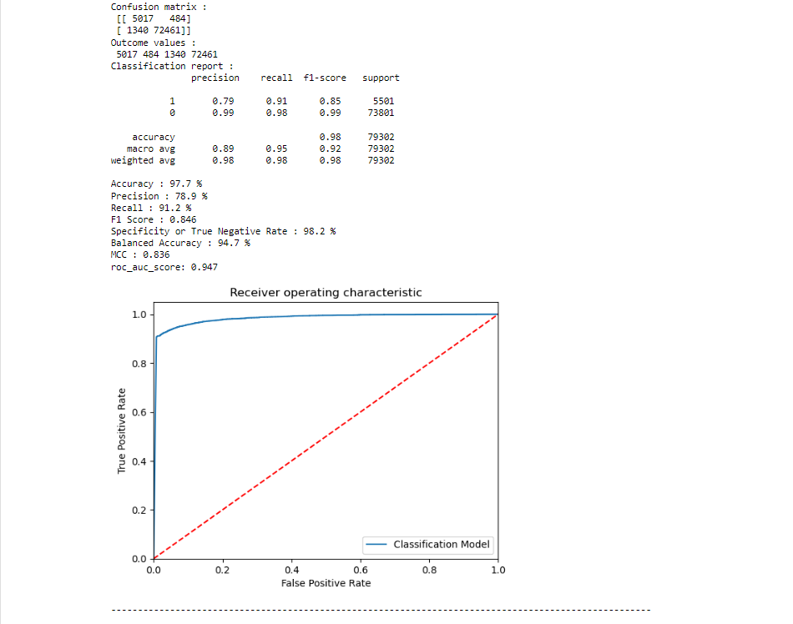

# Conclusions and Future work

**Over Sampling**: Extra Tree Classifier model performance is good, by considering the confused matrix, highest accuracy (0.996) & good F1 score (0.938). This is becauseExtra Tree Classifier uses bootstrap aggregation which can reduce bias and variance in the data and can leads to good predictions with claims dataset.

**Under Sampling**: Random Forest/ Extra Tree Classifier model are out performed Logistic Regression model, by considering the confused matrix, highest accuracy (0.989) & good F1 score (0.937). This is because Random Forest/Extra Tree Classifier uses bootstrap aggregation which can reduce bias and variance in the data and can leads to good predictions with claims dataset.

The model results in the following order by considering the model accuracy, F1 score and RoC AUC score.

1. **Extra Trees Classifier**  with Over and Under Sampling
2. **Random Forest** with Over Sampling
3. **Logistic Regression** with Under sampling

We recommend the model - **Extra Trees Classifier** with Over and Under Sampling technique as a best fit for the given Auto Insurance claims dataset. We considered the Extra **Trees Classifier** because it uses bootstrap aggregation which can reduce bias and variance in the data and can leads to good predictions with claims dataset.

**Note: Add results screen snapshot here**

The future work to evaluate the “Other Types Claims” in auto Insurance by using classification methods.

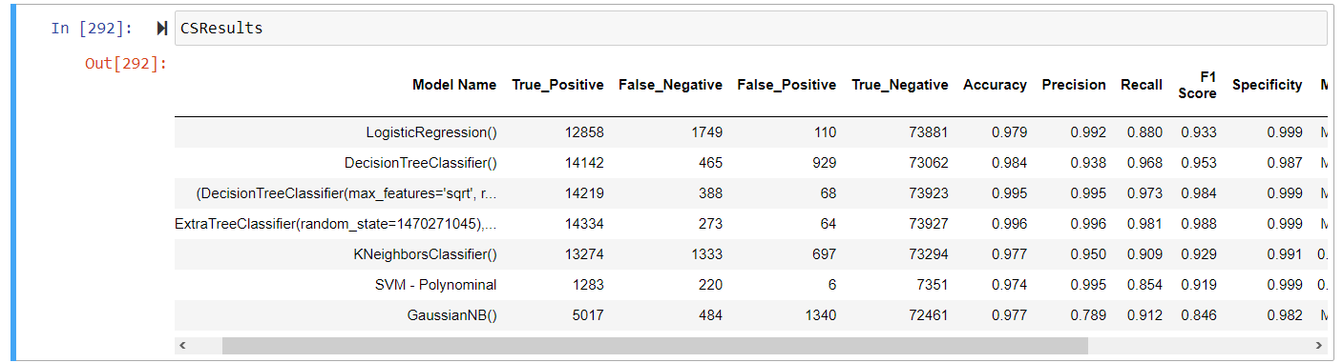

# References:

As an AI language model, I don't have browsing capabilities to provide real-time links. However, I can offer you a list of reputable sources where you can find valuable information for your auto insurance claim prediction AI/ML project. You can search for these references online using the provided titles:

1. "Predictive modeling for automobile insurance claims" - Journal of Risk and Insurance: https://onlinelibrary.wiley.com/doi/abs/10.1111/j.1539-6975.2007.00259.x

2. "Application of Machine Learning Techniques for Auto Insurance Claim Prediction" - IEEE Xplore: https://ieeexplore.ieee.org/document/7860340

3. "Insurance Claim Prediction using Machine Learning" - ResearchGate: https://www.researchgate.net/publication/337505648_Insurance_Claim_Prediction_using_Machine_Learning

4. "Machine Learning Techniques for Auto Insurance Fraud Detection and Claim Prediction" - Procedia Computer Science: https://www.sciencedirect.com/science/article/pii/S1877050920300925

5. "A Deep Learning Approach for Automobile Insurance Claim Prediction" - IEEE Xplore: https://ieeexplore.ieee.org/document/9172828

6. "Predictive Analytics in Automobile Insurance: A Survey" - International Journal of Engineering Research & Technology: https://www.ijert.org/research/predictive-analytics-in-automobile-insurance-a-survey-IJERTV8IS070358.pdf

7. "Data Mining for Insurance Claim Prediction" - International Journal of Computer Applications: https://www.ijcaonline.org/archives/volume145/number4/25034-2018912327

8. "Auto Insurance Fraud Detection and Claim Prediction using Machine Learning" - Proceedings of the 2019 IEEE/ACM International Conference on Advances in Social Networks Analysis and Mining: https://dl.acm.org/doi/10.1145/3341161.3342857

9. "Auto Insurance Claim Prediction Using Machine Learning Techniques: A Comparative Study" - Journal of Artificial Intelligence: http://aircconline.com/ijaia/V12N3/12320ijaia02.pdf

10. "Application of Machine Learning Algorithms for Auto Insurance Claim Prediction" - International Journal of Innovative Research in Computer and Communication Engineering: https://www.ijircce.com/upload/2017/december/19_Application.pdf

# Appendices:

## List of Charts

### Chart 01: Total Policy Premium:

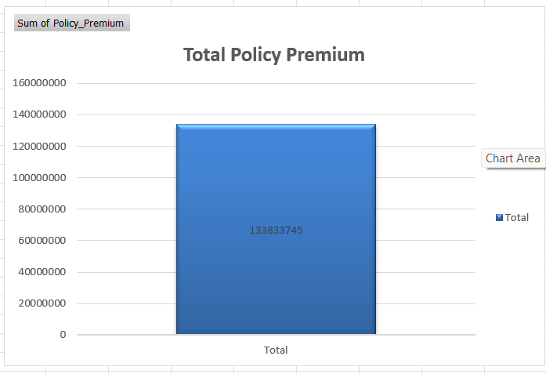

### Chart 02: Total Previous citations:

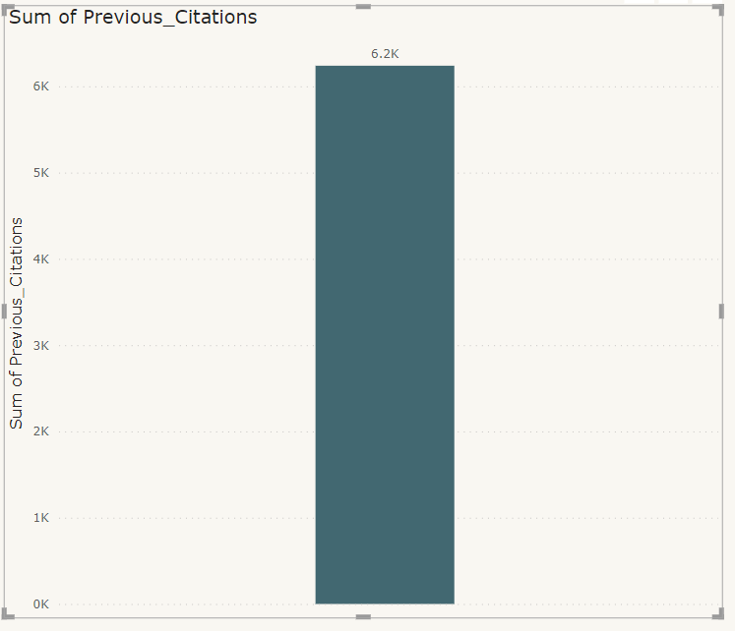

### Chart 03: Total Previous Accidents:

### Chart 04: Count by Profession

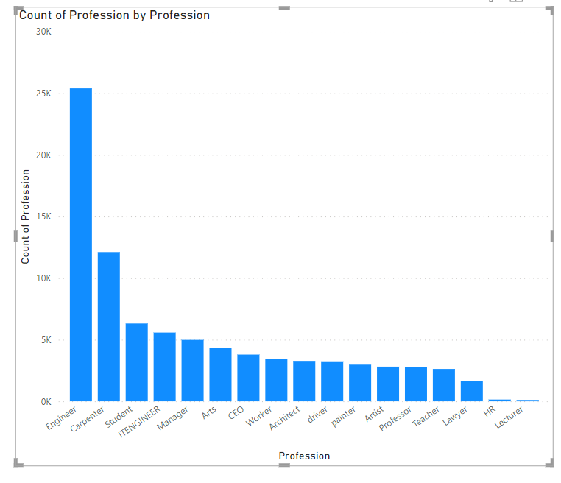

### Chart 05: Total claim paid out

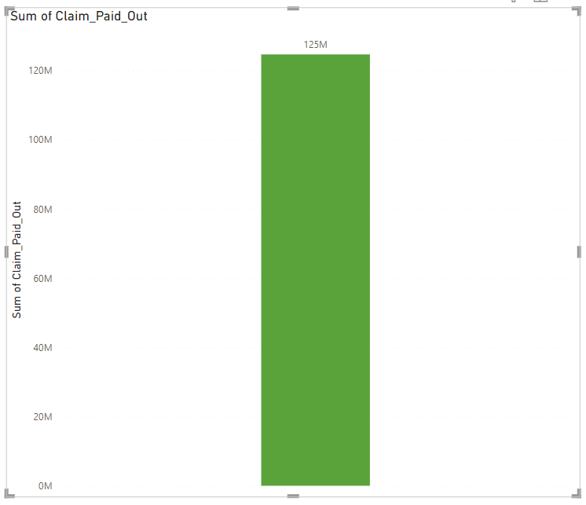

### Chart 05: Total claim paid out

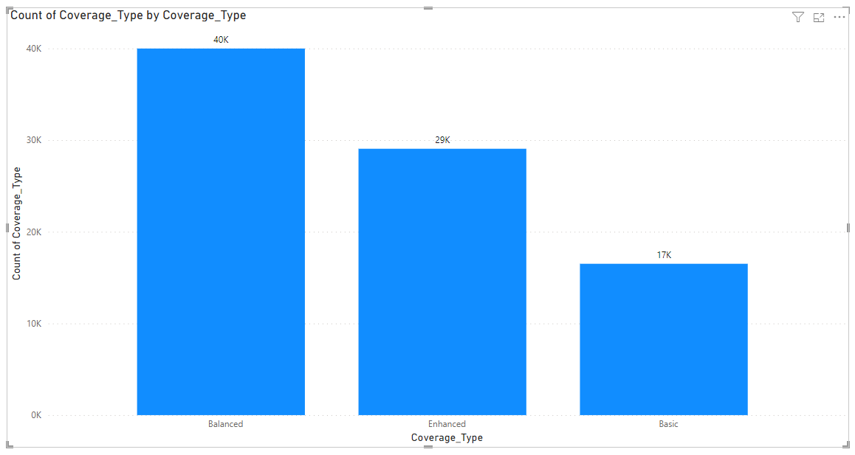

### Chart 06: Previous Accidents count based on no.of accidents occurred:

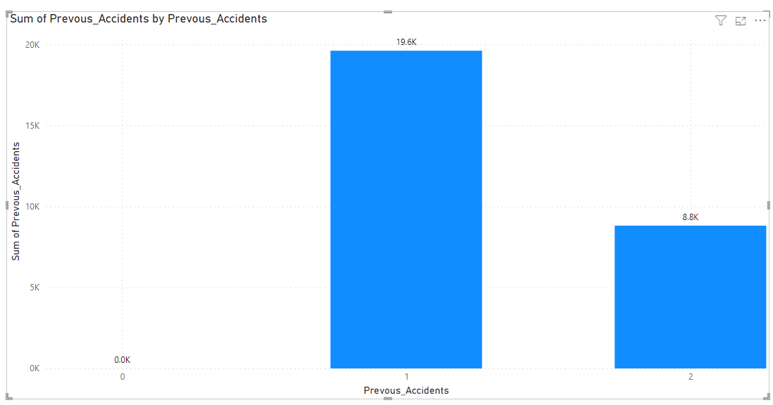

### Chart 07: Total count of different types of Education:

### Chart 08: Total Count of different types of Gender:

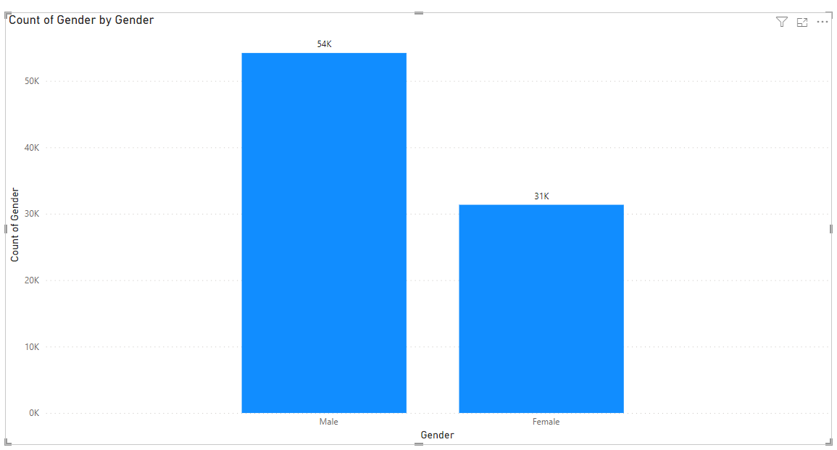

### Chart 09: Total Count of different Vehicles Make

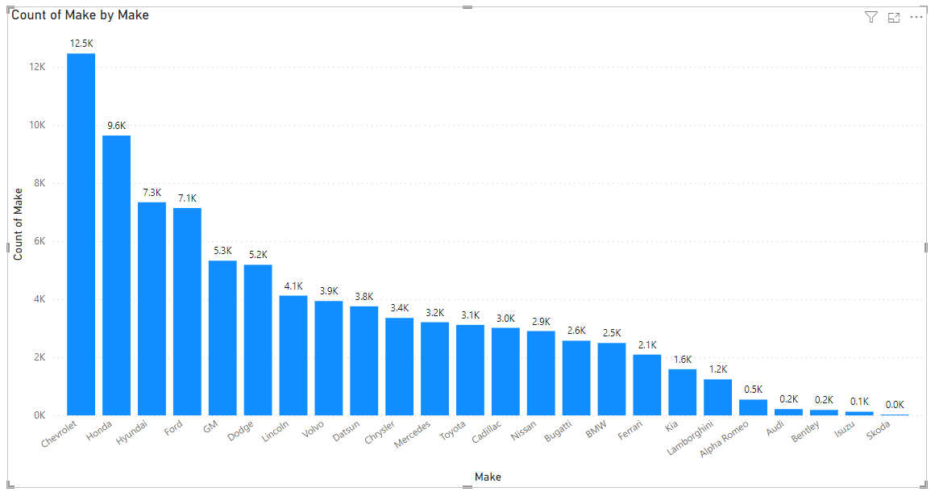

### Chart 10: Total Count of Different type of Marital status:

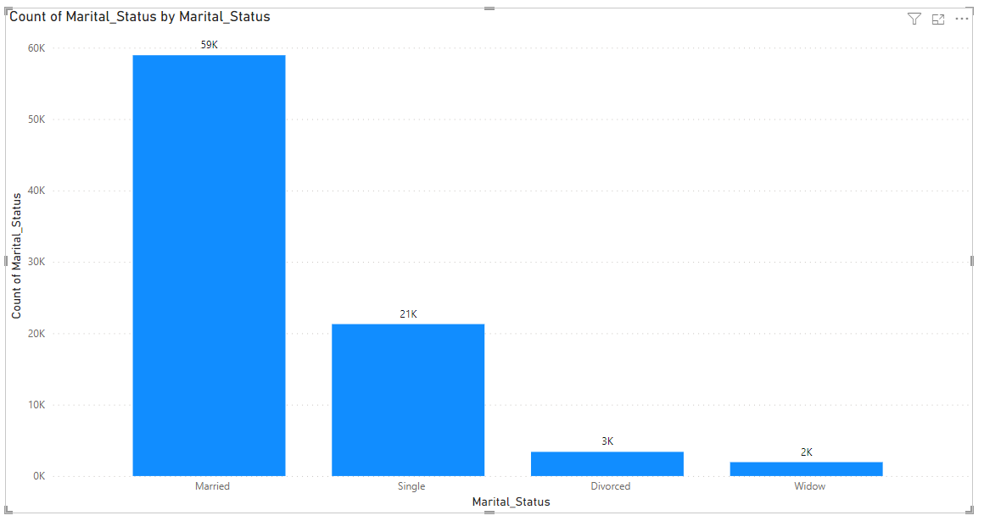

### Chart 11: Total Count of Police Filing:

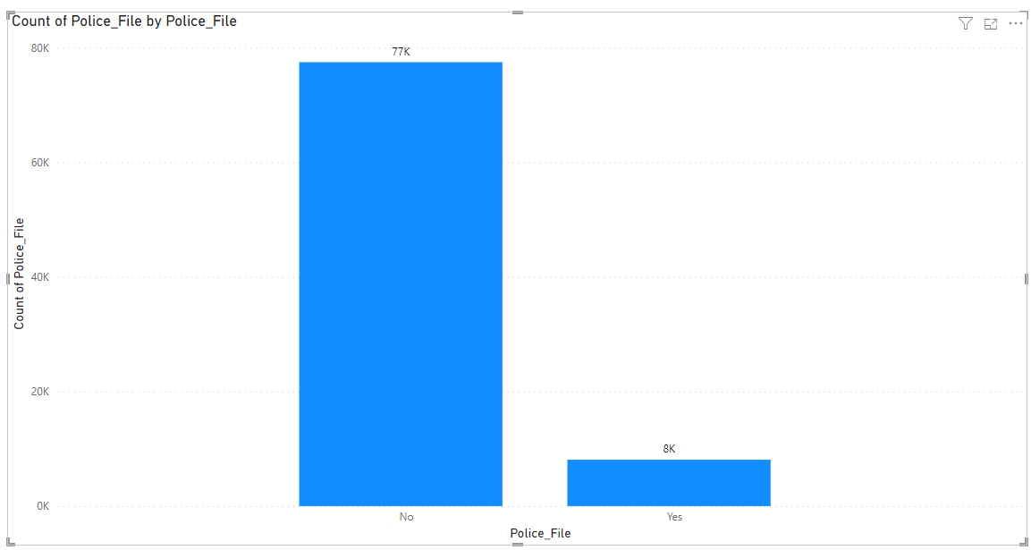

### Chart 12: Total Count of Type of Policy Types:

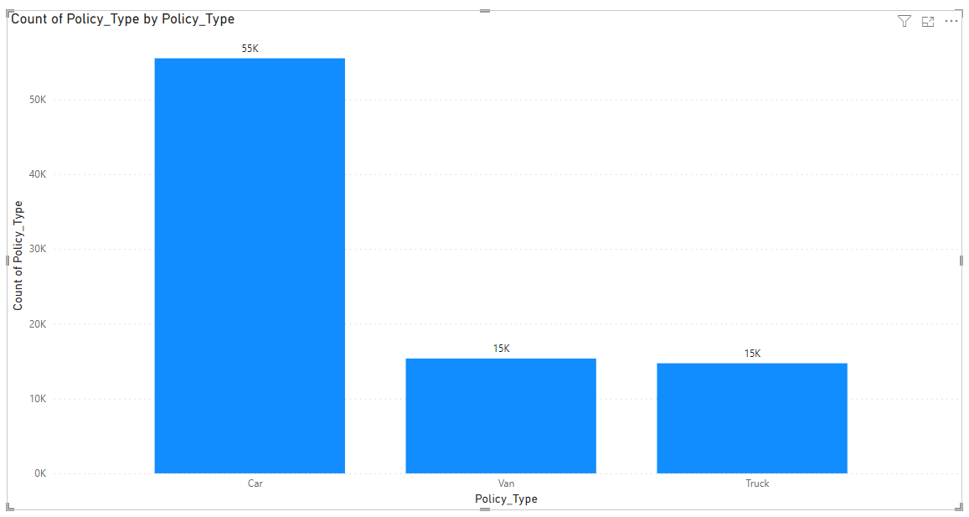

### Chart 13: Total Count of Type of Road types:

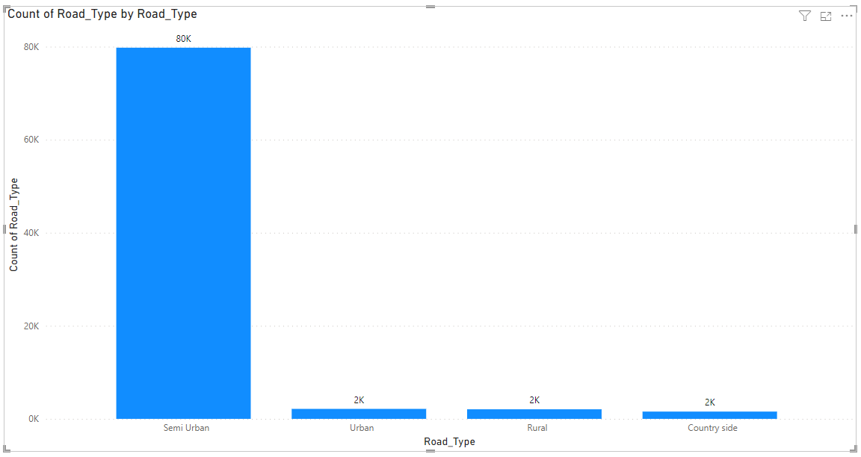

### Chart 14: Total Count of Type of State:

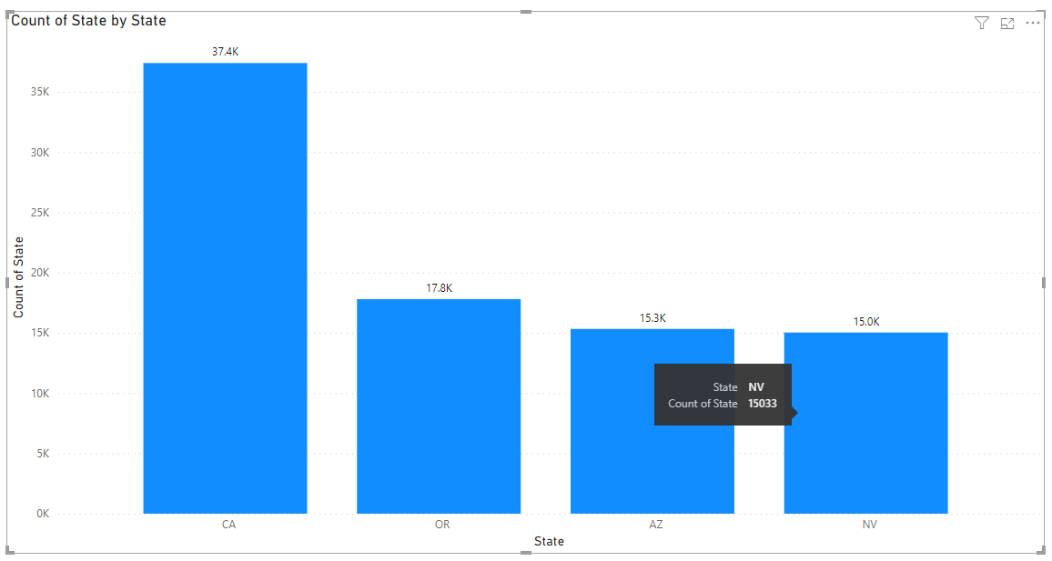

### Chart 15: Umbrella Policy

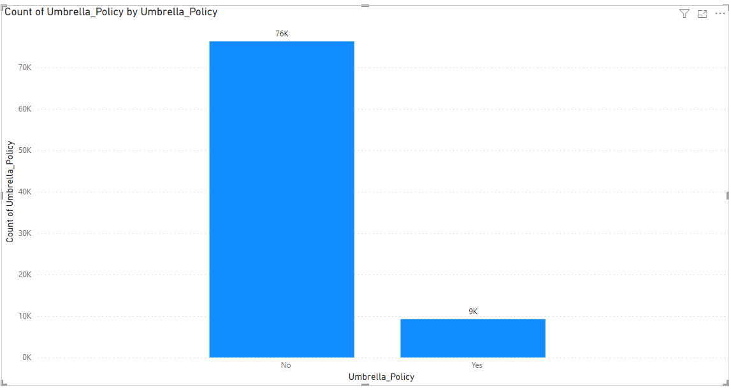

### Chart 16: Total count of different type of vehicle usage

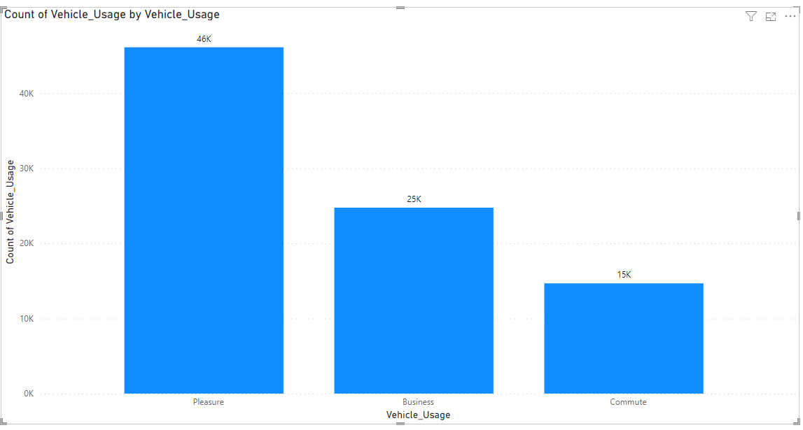

### Chart 17: Total Count of types of Eye Witnesses:

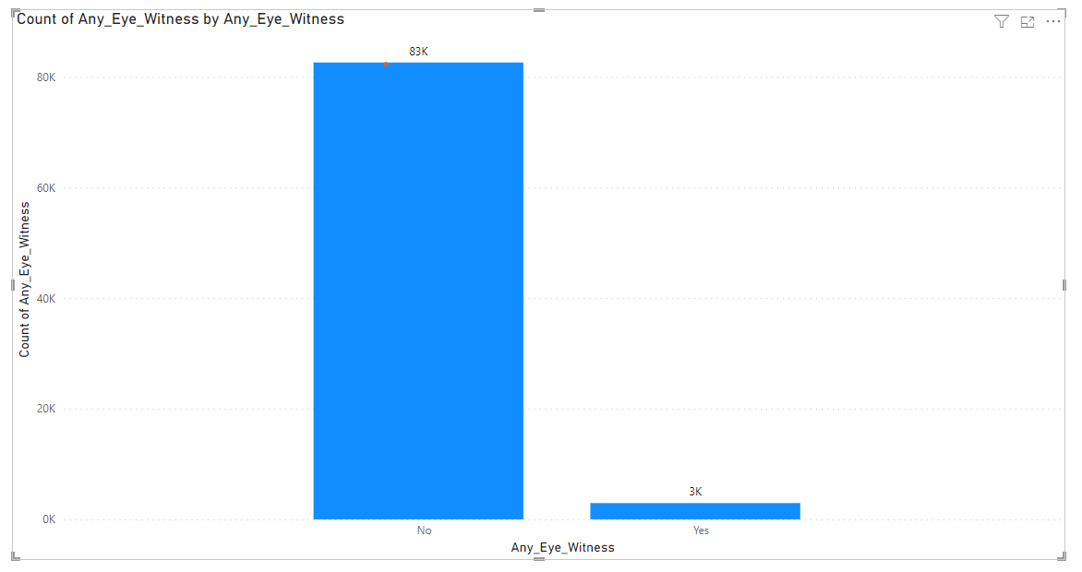

### Chart 18: Analysis of claims by Year, Gender and Marital Status:

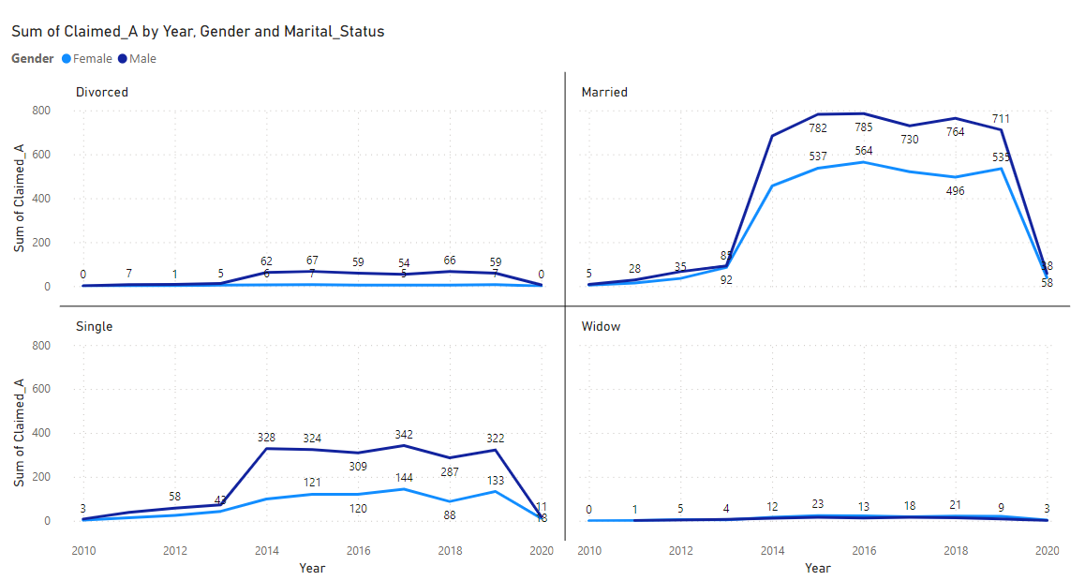

### Chart 01: Analysis of claims by Year, Education and Marital Status

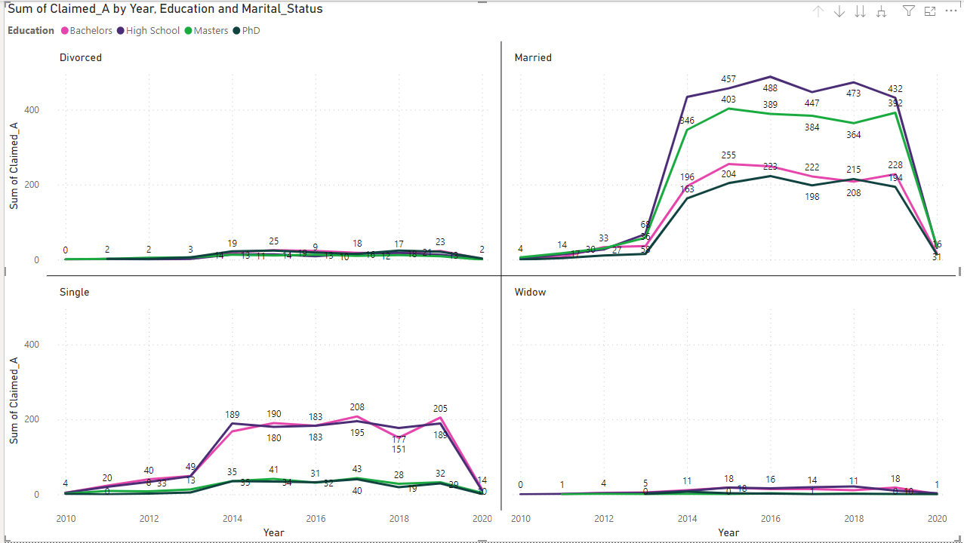

## List of Charts

### Line chart 01: Claim Trend with Prediction for next 5 years(with Claim Actual values from Over Sampling Extra Tree Classifier model analysis):

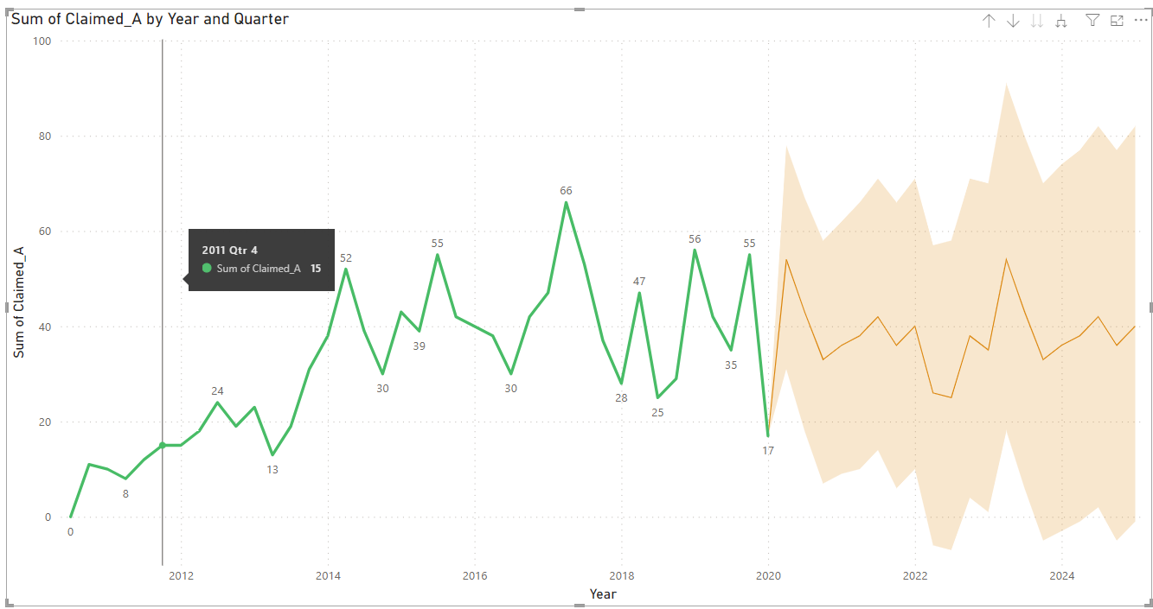

### Line chart 02: Claim Trend with Prediction for next 5 years(with Claim Actual values from Under Sampling Extra Tree Classifier model analysis):

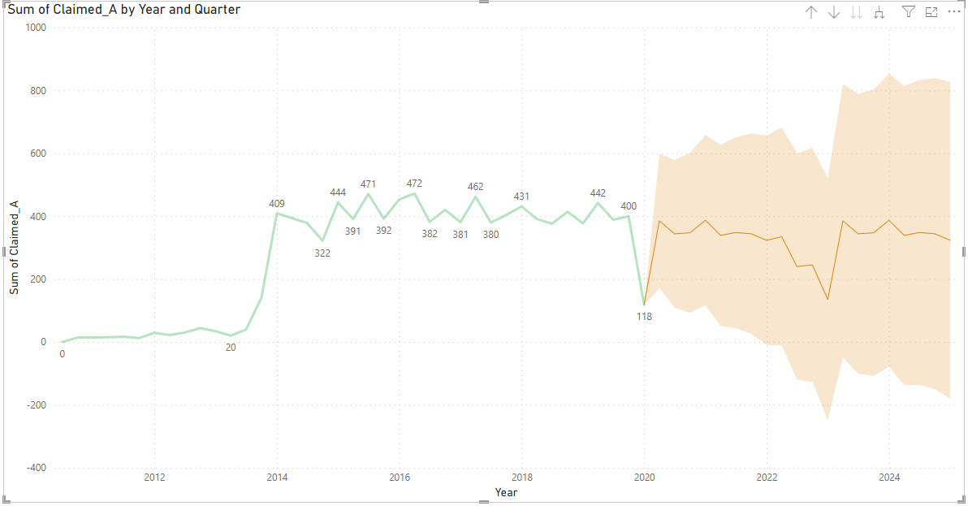

### Line chart 03: Claim Trend with Prediction for next 5 years(with claim predicted values from Over Sampling Extra Tree Classifier model analysis):

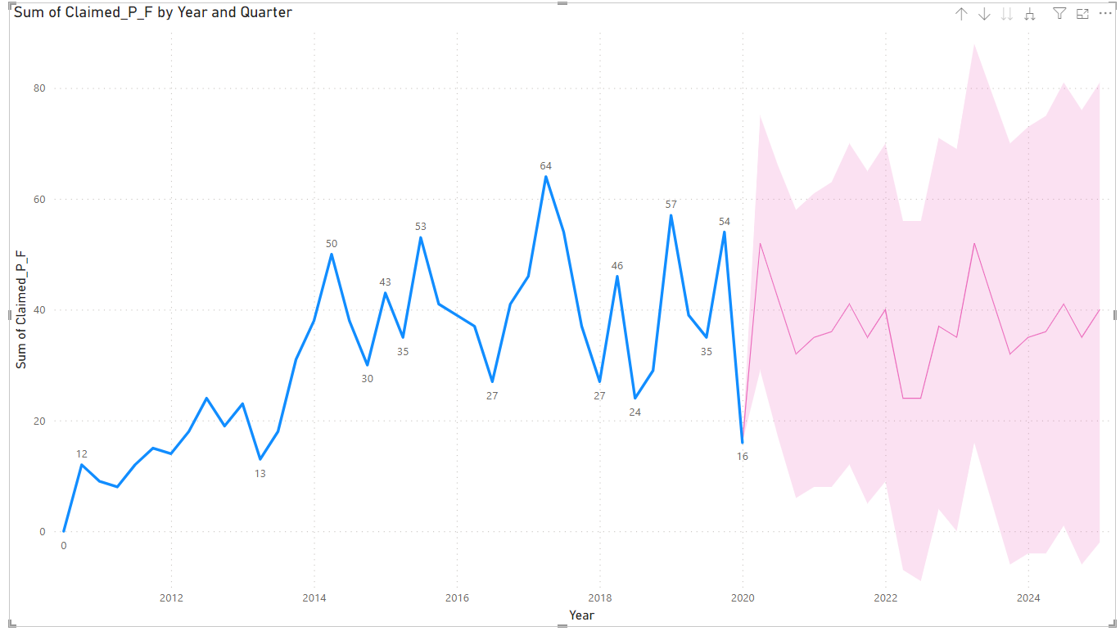

### Line chart 04: Claim Trend with Prediction for next 5 years(with Claim Actual values from Under Sampling Extra Tree Classifier model analysis):



 